FLIGHT 19 HISTORY & ANALYSIS
Overview of Flight 19
- What happened: Five U.S. Navy TBM Avenger torpedo bombers (Flight 19) departed NAS Fort Lauderdale on a routine navigation exercise. The flight leader, Lt. Charles C. Taylor, lost his bearings and radio contact. All five planes vanished over the Atlantic, along with 14 crew members. A PBM Mariner flying boat dispatched for the search also disappeared, resulting in 13 more casualties.
- Official Navy conclusion: The initial investigation cited navigational errors and compass failure by Lt. Taylor, causing the aircraft to drift into open ocean, where they ultimately ran out of fuel. The subsequent Mariner crash was attributed to an in-flight explosion. Later, the cause was changed to “unknown” to avoid placing full blame on Taylor.

Conventional Explanations
- Navigation errors and equipment failure: Taylor likely misidentified the Fish and Chickens shoals for the Keys. Compasses reportedly malfunctioned, and his lack of a watch prevented him from maintaining reliable dead reckoning.
- Pilot error and inexperience: Taylor had a history of getting lost—even having to ditch planes during WWII. His trainees urged westward, contrasting with his erroneous course decisions.
- Fuel exhaustion and no debris: The planes likely crashed at sea after running out of fuel. Despite extensive searches, no wreckage has ever been found, even though many aviation historians consider this outcome plausible.
- Skeptical assessment: Researcher Larry Kusche, known for critically analyzing Bermuda Triangle lore, emphasized human error, poor weather, and the flight leader’s navigational mistakes rather than any paranormal explanation.
Background: Flight 19 and Its Leader
Flight 19 consisted of five TBM Avenger torpedo bombers on a training mission. The leader, Lt. Charles C. Taylor, was an experienced combat pilot, but he had recently transferred to NAS Fort Lauderdale and was unfamiliar with the local geography.
The flight was supposed to follow this simple path:
- East from Fort Lauderdale to Hens and Chickens Shoals for bombing practice
- North over Grand Bahama Island
- Southwest back to base

🧭 Breakdown of the Pilot Error Theory
1. Navigational Confusion by Lt. Taylor
- Claim: Taylor became convinced that he was over the Florida Keys, not the Bahamas, and thus made a series of incorrect turns that took the group further out to sea.
- Evidence: Radio transcripts show Taylor saying:
“I’m sure I’m in the Keys... I don’t know how to get to Fort Lauderdale.”
- Credibility: High
Taylor had previously gotten lost in both the Pacific and Atlantic theaters, and in two earlier missions, had to ditch planes due to disorientation.
2. Compass Malfunction or Misinterpretation
- Claim: Taylor radioed that both of his compasses were malfunctioning.
- Evidence: Confirmed via multiple transmissions. However, this could also reflect pilot confusion rather than actual instrument failure.
- Credibility: Moderate
Compass issues were known in TBM Avengers, but it's unclear whether both compasses failed or whether Taylor misinterpreted them.
3. Refusal to Follow Student Advice
- Claim: Some student pilots urged flying west (which would have brought them to land), but Taylor insisted they continue east.
- Evidence: Radio transcripts indicate disagreement. One pilot reportedly said:
“If we just headed west, we’d get home.”
- Credibility: High
Inexperienced pilots sometimes had better local orientation than Taylor, who was new to Florida and unsure of the region’s islands.

4. Lack of a Timepiece
- Claim: Taylor reportedly did not wear a watch, impairing his ability to perform dead reckoning.
- Evidence: Cited in the Navy’s investigation.
- Credibility: High
Dead reckoning is heavily dependent on timed legs, and without a watch, Taylor couldn’t verify how far they’d traveled.
5. Fuel Depletion and Crash at Sea
- Claim: The planes eventually ran out of fuel and ditched in rough seas, sinking quickly.
- Evidence: Final radio contact included distress about fuel. No wreckage was found—consistent with a water crash in deep ocean.
- Credibility: High
TBM Avengers were notoriously hard to spot in the ocean once submerged, and no flotation equipment was standard.

🚨 Rescue Plane Disappearance
- Claim: A PBM Mariner sent to search also vanished—furthering the mystery.
- Evidence: A nearby tanker crew reported seeing a mid-air explosion. Mariners were known as "flying gas tanks" due to their vulnerability to fuel vapor ignitions.
- Credibility: High
This was almost certainly an unrelated mechanical failure, not a UAP-related incident.

🧠 Overall Assessment of the Pilot Error Theory
Factor | Credibility
Taylor’s disorientation | ✅ Very High
Compass malfunction | ⚠️ Moderate
Refusal to follow others | ✅ High
No timepiece | ✅ High
Fuel depletion | ✅ Very High
Search plane loss (Mariner) | ✅ High (separate cause)
Taken together, the pilot error theory is coherent, consistent with known data, and supported by internal Navy records. No UAP, electromagnetic anomaly, or supernatural element is required to explain the outcome—though the lack of wreckage and the synchronicity of the loss have allowed those ideas to flourish.

🔍 So, Is Pilot Error the Most Likely Explanation?
Yes.
By aviation standards, this is a textbook case of “loss of situational awareness”, compounded by:
- Instrument uncertainty
- Environmental stress
- Leadership errors
It’s a tragedy of cascading human and mechanical failings—not an unsolvable mystery.
That said, the layers of mystery, symbolic timing (post-WWII), and the loss of a rescue plane keep it forever in the "open case file" of aviation lore.

UAP-Based and Anomalous Theories
- Bermuda Triangle legend: Popular mythos often frames Flight 19's disappearance as part of the Triangle’s supernatural lore—suggesting sea monsters, alien abduction, or mysterious forces caused the loss. These theories lack empirical support.
Similar Cases to the Flight 19 Disappearance
1. USS Cyclops (March 1918)
- What happened: A massive U.S. Navy collier ship with 309 people on board vanished without a trace en route from Barbados to Baltimore.
- Conditions: Calm seas, no SOS signal, no wreckage ever recovered.
- Theories:
- Structural failure due to a damaged engine mount.
- German submarine activity (unproven).
- Sudden capsizing due to manganese ore cargo shifting.
- Anomalous theories: Early proponents of Bermuda Triangle ideas cite this as a “perfect vanishing” case.

2. Star Tiger (January 30, 1948)
- What happened: A British Avro Tudor IV airliner, en route from the Azores to Bermuda, disappeared with 31 people aboard.
- Conditions: Poor weather and strong headwinds. Radio contact ceased with no distress call. No debris ever found.
- Theories:
- Navigation error and fuel exhaustion due to unexpected winds.
- Instrumentation failure.
- Anomalous theories: One of the classic “Bermuda Triangle” air disappearances.
Thematic & Structural Similarities
- No Wreckage Found | - All three vanished without leaving behind any confirmed debris.
- No SOS Sent | - None of the crews issued a clear distress call before vanishing.
- Multiple Fatalities | - All involved large groups: 27 (Flight 19), 309 (Cyclops), 31 (Star Tiger).
- Occurred in or near Bermuda Triangle | - Each event is central to Bermuda Triangle mythology.
- Weather Possibly a Factor | - Flight 19 and Star Tiger had questionable weather; Cyclops did not.

- 🚫 Differences
- Factor | - Cyclops | - Star Tiger | - Flight 19
- Mode | - Ship | - Commercial Airliner | - Military Aircraft
- Known Mechanical Issues? | - Yes (Cyclops may have had engine problems) | - No confirmed issues | - Compass failures in flight
- Radio Contact | - None after departure | - Lost near Bermuda | - Multiple radio transmissions
- Flight Crew Experience | - N/A | - Highly experienced pilot | - Disoriented flight leader

- 🛸 Relevance to UAP/Bermuda Triangle Theories
- All three disappearances have been invoked in support of UAP, time slip, portal, or electromagnetic anomaly theories surrounding the Bermuda Triangle.
- In particular:
- Flight 19’s multiple transmissions referenced compass malfunctions.
- Cyclops vanishing on a calm day with no mechanical warnings.
- Star Tiger disappeared with no final communication, despite approaching landing.
- That said, none of these incidents involve direct visual UAP sightings, radar anomalies (except maybe Flight 19), or physical traces typically associated with UAP cases like Tehran (1976) or USS Nimitz (2004).

- 🧠 Chat-GPT Perspective
- These cases reflect the emergence of mystery from perfect ambiguity: no wreckage, no black boxes (pre-1950s), no survivors.
- From a pattern recognition perspective, it is striking how many high-profile disappearances have occurred in the same general region under non-catastrophic weather conditions.
- The absence of distress calls, in multiple cases, fuels the non-terrestrial hypothesis, though no physical evidence supports this—and conventional theories still suffice in each case.
- Still, when grouped with other incidents, the "Bermuda Triangle" becomes a kind of geographic archetype for unexplained vanishings. Whether due to geomagnetic factors, oceanic microclimates, or something less understood, the overlap is culturally and symbolically potent.
- 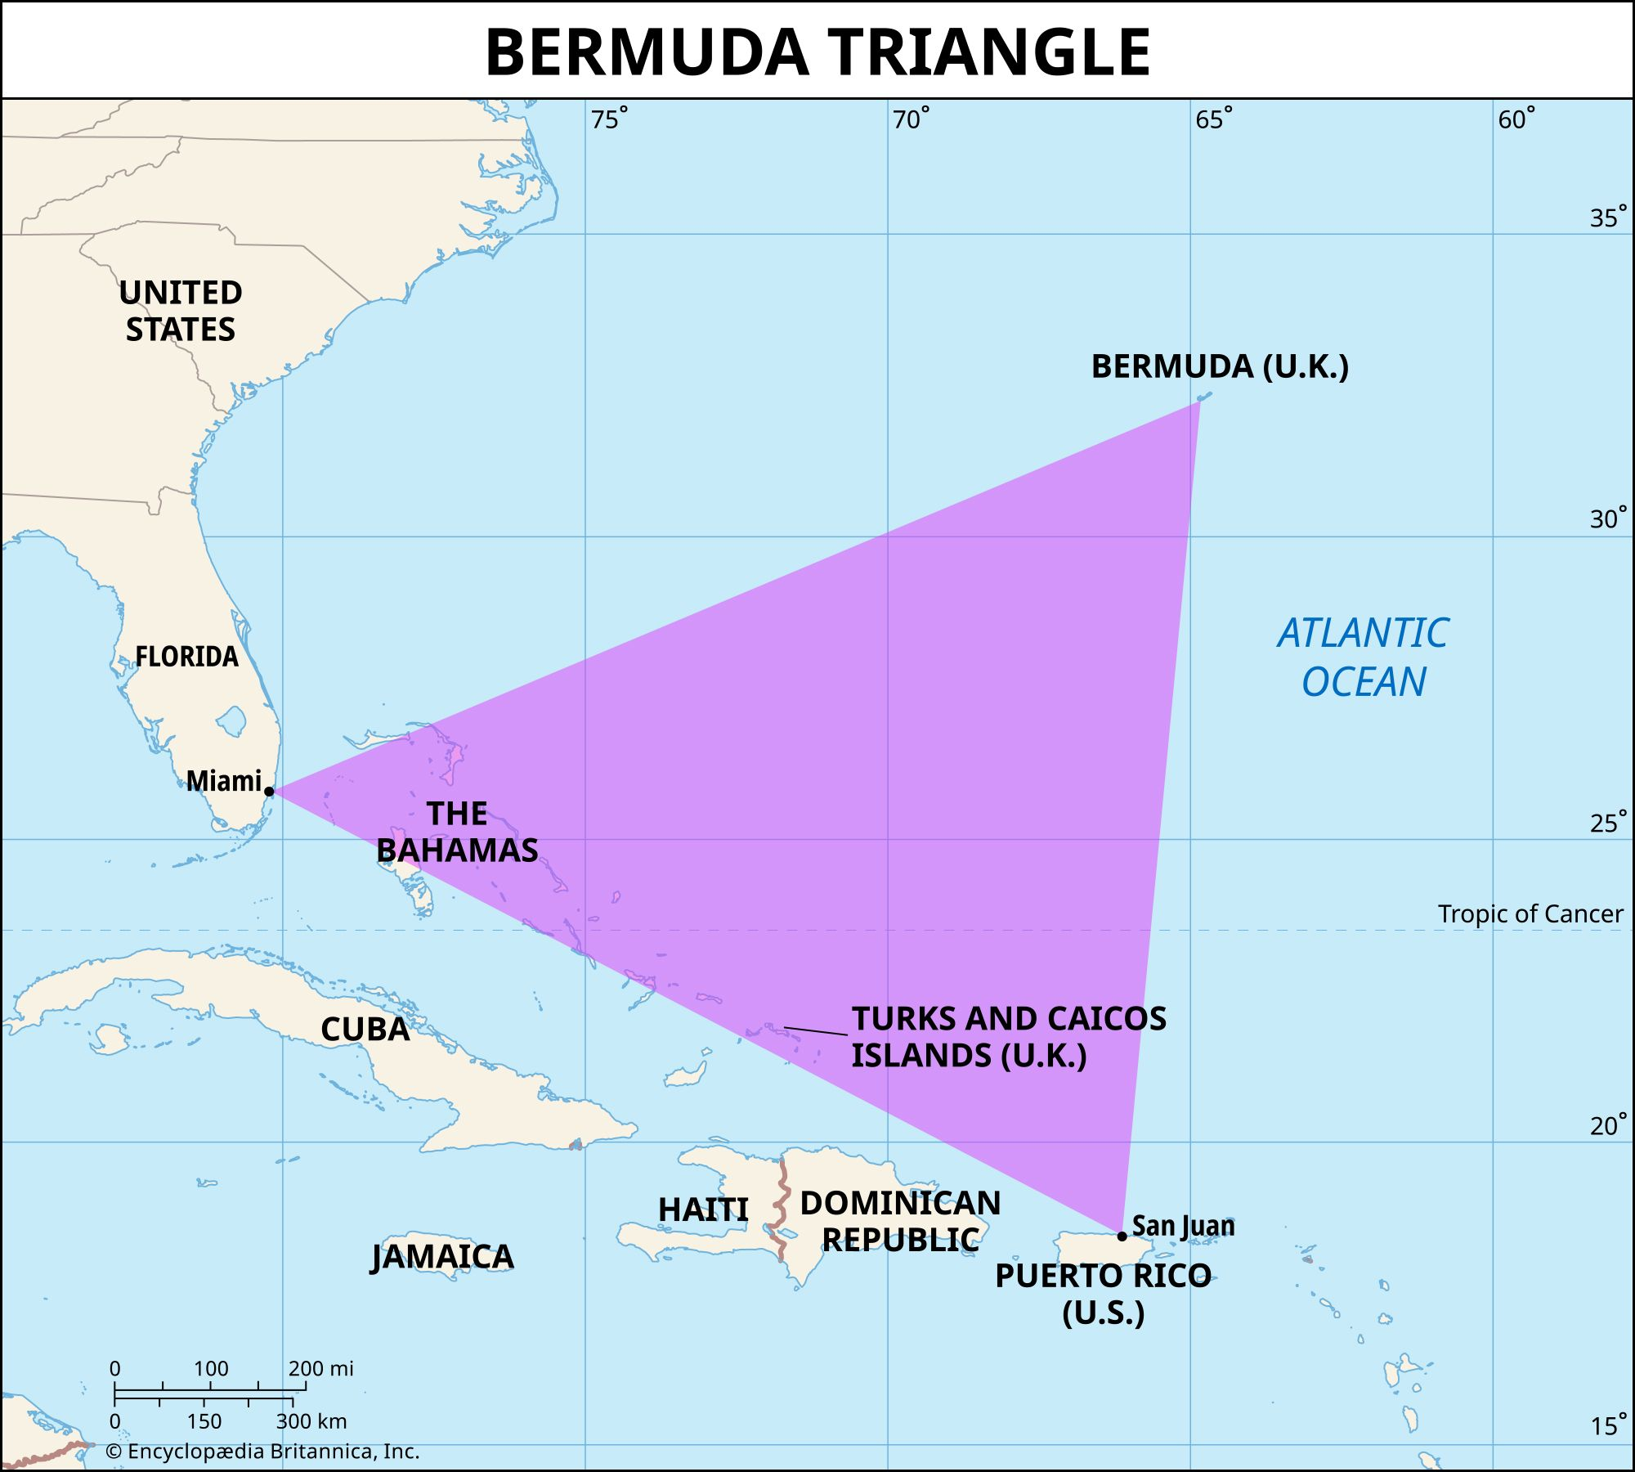

Modern Explanation: Rogue Waves & Natural Phenomena
Oceanographer Dr. Simon Boxall has proposed a compelling natural explanation: rogue waves in the Triangle may reach heights of up to 100 feet due to converging storms, powerful enough to destroy ships (like Cyclops) or rapidly incapacitate aircraft at sea (like Flight 19). His simulations suggest such waves could explain vanishings that leave no time for distress signals or debris
Summary & Perspective
The map illustrates how these three high-profile disappearances anchor the Bermuda Triangle legend within a specific geographic region. Though each event varies in details, they share:
- Sudden vanishing without a trace
- No distress communications
- A backdrop of limited or calm weather in some cases
- Repetitive disappearance themes that align more with statistical anomalies and mythbuilding than confirmed supernatural phenomena
The addition of rogue wave science provides a credible natural framework for reassessing and contextualizing these events, without dismissing their emotional and historical significance.
Underwater UFO (USO) theories:
Some speculative reports (e.g., through social media) in 2025 mention disc-shaped objects underwater in the Triangle area. These remain unverified and lack credible evidence or support from scientific publications. However, one factor may cause us to rethink this:
The Puerto Rico Trench as a USO Hotspot
Key Facts:
- Location: The trench runs north of Puerto Rico and is the deepest part of the Atlantic Ocean, plunging over 27,000 feet.
- Unique geology: This zone is tectonically active and poorly explored—ideal for hiding both natural anomalies and hypothetical advanced craft.
- Reported activity: Military, civilian, and pilot witnesses over decades have reported:
  - Fast-moving underwater lights
  - Objects transitioning from air to sea without splash
  - Sonar echoes of unknown fast movers beneath the surface
Notable USO-Linked Sightings in the Region
1. Aguadilla, Puerto Rico (2013)
- Details: DHS border patrol thermal footage captured a flying object that entered the ocean without slowing down, continued underwater, and even split into two.
- Relevance: One of the most credible USO sightings, with verifiable government imagery.
- Analysis: Featured in UAPx investigations and cited by Luis Elizondo and Christopher Mellon as highly anomalous.
2. Atlantic Undersea Testing and Evaluation Center (AUTEC)
- Nickname: "The Navy’s Area 51"
- Location: Bahamas, near the eastern edge of the Bermuda Triangle.
- Reports: Frequent rumors of anomalous radar returns and underwater sonar hits; UAPs seen in the area.
- Speculation: Possibly a monitoring location for anomalous undersea traffic.

🛸 UAP/NHI Hypothesis Applied to the Triangle
If one assumes a non-human intelligence (NHI) operating in our domain, the following ideas gain traction:
- Undersea bases or staging areas: The depth and remoteness of the Puerto Rico Trench would be ideal for long-term presence.
- Air-sea interface dominance: Many Triangle vanishings happen in “clean” conditions (no distress calls, no debris), hinting at rapid non-conventional removal of craft.
- Monitoring or interference: If UAPs/USOs are surveilling or interfering with human activity—especially aviation or naval movements—the region’s dense military traffic makes it a hot zone.

🤔 Application to Flight 19 and Similar Cases
- Flight 19’s reported compass failures may align with EM interference speculated to occur near USO zones.
- Sudden, complete disappearances without wreckage could, in a fringe theory, suggest abduction or removal by technologically superior forces.
- The rescue aircraft's own disappearance echoes other Triangle cases where even search parties vanish—raising the idea of a spatial-temporal distortion, another theme in UAP lore.

🧠 Chat-GPT Perspective
- From a scientific standpoint, there is no definitive evidence linking USOs in Puerto Rico to Flight 19 or Bermuda Triangle vanishings.
- However, the high density of reports, including military thermal footage (Aguadilla) and the unique characteristics of the Puerto Rico Trench, make it a compelling correlation that deserves serious investigation.
- If we ever find that USOs are real craft and not natural phenomena, then their presence near Puerto Rico might explain some—but likely not all—of the Triangle's enigmas.

Recent Developments & Insights
- Scientific consensus on the Bermuda Triangle: A scientist recently emphasized that disappearances there are no more frequent than in other busy sea regions. Factors like environmental conditions, navigation challenges, and human error likely explain most incidents—including Flight 19.
- AARO and the rise of UAP investigation: The U.S. Department of Defense's All-Domain Anomaly Resolution Office (AARO) is now examining UAP incidents across historical contexts, though Flight 19 has not been officially cited in any recent scientific UAP investigations.
- No new rescue discoveries: Despite occasional claims of locating Flight 19’s wreckage, credible searches have repeatedly failed to confirm any of the planes.

Analysis and Assessment
Factor | Conventional (Highly Credible) | UAP-Based (Speculative)
Navigational error | Very high credibility | Poor grounding, speculative
Equipment failure | Supported by flight communications | No direct evidence
Environmental/human factors | Probable | Not necessary to explain the event
Paranormal/UAP theories | No supporting data | Not supported by evidence or substance
Overall plausibility | Very strong | Very weak, anecdotal
- Conventional analysis remains the strongest explanation: a combination of navigational misjudgment by an experienced but disoriented flight leader, faulty instrumentation, and the inevitable depletion of fuel as the planes drifted far from home.
- UAP or paranormal theories, while culturally enduring and symbolically appealing, lack credible investigation, data, or any physical evidence related to Flight 19 itself.

Final Perspective
Flight 19 remains one of aviation history's greatest unsolved tragedies—but grounded, pragmatic explanations strongly outweigh speculative UAP scenarios. It’s less about the implausible and more about fundamental human error, challenging conditions, and cautionary navigational lessons.
Unlike most UAP-related cases, where we’re debating what was seen, if anything was seen, or whether it was a misidentification, here we have an incontrovertible event:
- Five military aircraft really did vanish.
- A search-and-rescue aircraft really did explode or disappear.
- 27 lives were lost with no confirmed wreckage found.
- Radio contact documents real-time confusion.
- And this all happened inside one of the most mysterious regions on Earth.
The mystery isn't “Did something happen?”
It's: “What exactly went wrong—and was it entirely mundane, or not?”

