Tunguska Event & Analysis
What happened at Tunguska (1908)
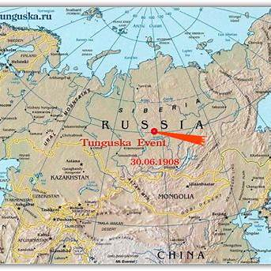
On the morning of June 30, 1908, something exploded high above the taiga near the Podkamennaya (Stony) Tunguska River in central Siberia. Witnesses described a bright fireball, followed by shock waves and intense heat; reports include people being knocked down and windows breaking far away. Instruments across Eurasia recorded seismic/pressure effects, despite the region's remoteness.
The blast flattened roughly ~2,000–2,150 km² of forest (often described as tens of millions of trees) and scorched portions of the surrounding area—yet no obvious impact crater was found.
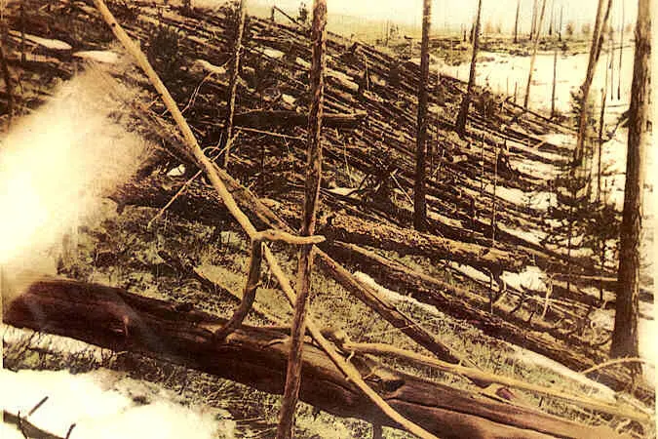
The leading “likely” explanation: an atmospheric airburst
The mainstream scientific view is that the Tunguska event was an airburst: a small near-Earth object entered the atmosphere and disintegrated/exploded before reaching the ground, releasing energy comparable to that of a large thermonuclear weapon and generating a powerful blast wave.
Why this fits the evidence:
- No crater is expected if the object breaks up in the air. Encyclopedia Britannica+1
- The radial tree-fall pattern and wide-area flattening are consistent with a shock wave from an aerial explosion. Encyclopedia Britannica+1
Asteroid vs. Comet
Within the airburst model, the two most-discussed culprits are:
1) A stony asteroid (often considered slightly more likely today):
A rocky body tends to deposit a lot of kinetic energy explosively when it fragments under intense pressure/heat, matching “blast-like” damage patterns and leaving only sparse microscopic debris.
2) A small comet (icy body):
A cometary fragment could also airburst and might better explain why macroscopic meteorite fragments are so scarce—ice and dust are less likely to survive as big chunks on the ground. Historically, this has been a popular scientific alternative.
Less-likely explanations (and why they’re generally disfavored)
Over the decades, many exotic ideas have circulated (e.g., methane release, electrical phenomena, antimatter, etc.). They persist partly because early fieldwork was delayed and the site is remote, leaving room for speculation. But the combination of instrumental records, blast footprint, and modern impact/airburst physics keeps the airburst explanation as the consensus.
Could the cause have been UFO/UAP-related?
While highly unlikely, some UFO/UAP-related theories have emerged as a possible cause for Tunguska because (1) the blast looked “nuclear” to later observers, (2) there was no obvious crater, and (3) serious field investigation didn’t happen until years later, leaving room for speculation.
The big UFO/UAP-flavored theories (fringe, but culturally influential)
1) “Exploded alien spacecraft” (the classic)
- After Hiroshima/Nagasaki, Soviet sci-fi writer Alexander Kazantsev popularized a story-version idea that Tunguska resembled a nuclear-powered spaceship accident overhead. That concept spilled beyond fiction and became a recurring “maybe it was a craft” theory in pop culture. Space+2Cambridge University Press & Assessment+2
- It’s essentially the template you still see today: “no crater + huge energy = not a normal meteor.” (Mainstream science disagrees; an airburst explains “no crater.”)
2) “UAP-related attack / interception”
- A variation says a craft was shot down, self-destructed, or was “intercepting” something and detonated. You’ll often see it paired with the idea that the blast pattern is “too clean” or “too strategic.”
- There’s no solid evidentiary chain supporting this; it’s largely narrative inference built on the same ambiguities above (remote site, limited direct remnants).

3) Modern “expeditions found evidence of a spaceship” claims
- Periodically, groups announce they’ve found signs of an “alien craft” at Tunguska; this has been treated skeptically by asteroid/comet specialists and science outlets.

Why Tunguska is a useful case study for UFO/UAP methodology
If you’re wearing your UAP-investigator hat, Tunguska is almost a “lab example” of how extraordinary explanations flourish:
- Ambiguous physical signature: a massive effect without the “expected” artifact (no clear crater).
- Time delay + sparse instrumentation: early data gaps create permanent uncertainty pockets.
- Analogy bias: post-1945 “it looks nuclear” framing helped seed the spaceship narrative.
What about some of the other unique theories about what caused the Tunguska event?
UFOs/UAP are not the only “outside the box” sort of theories about what may have happened at Tunguska:

1) The antimatter object hypothesis

The core idea
A meteoroid/comet fragment contained a meaningful amount of antimatter. When it hit the atmosphere, matter–antimatter annihilation would convert mass directly into energy, producing a Tunguska-scale blast without leaving a normal meteorite or crater.

Where it came from (it’s not just crank stuff)
This one actually had a “respectable” moment: in 1965, Cowan, Atluri, and Libby published a Nature paper proposing possible antimatter content for the Tunguska body, tying it to radiocarbon (¹⁴C) considerations. Nature+1

Thought-Provoking Questions:
If a chunk of antimatter annihilated in the atmosphere, you’d expect:
- A burst of high-energy radiation (gamma rays) and particle cascades.
- Lots of secondary neutrons, which should increase atmospheric radiocarbon (¹⁴C) and show up in tree rings (potentially beyond just the local area).

Why it’s largely considered unlikely now
Follow-up work and critiques undercut the key “signature”:
- A Nature study (Lerman, Mook, Vogel, 1967) looked at radiocarbon in tree rings and addressed whether Tunguska produced the kind of global ¹⁴C signal you’d expect. Nature+1
- Additional discussion in Nature (including critiques/defenses around the neutron assumptions) kept the debate alive briefly but didn’t establish a strong radiocarbon “smoking gun.”
Conclusion: This is a fun “real scientists asked a wild question” story: they tried to use tree rings as a forensic detector for annihilation physics.

2) The micro black hole (primordial black hole) hypothesis

The core idea
In 1973, Jackson and Ryan published a short Nature paper asking whether Tunguska could be caused by a tiny black hole passing through Earth—often framed as a primordial black hole. Nature+1
The appeal is obvious: a black hole wouldn’t leave meteorite fragments or a crater, so it “explains” the missing impactor.

What it would predict (the part most people skip)
A through-and-through transit implies:
- A track through Earth (gravitational/thermal effects along a narrow path).
- Some exit-side disturbance (not necessarily a second Tunguska, but something that seismology/atmospheric records might notice).
- A distinctive seismic signature and geometry that could be checked against stations that recorded the event. (The 1973 authors were explicitly trying to make it falsifiable in principle.)

Why it’s not favored
In plain terms, it’s a very high-concept explanation that struggles to outperform the much simpler airburst model, and it leans on effects that we’d expect to have shown up more cleanly in global records if an object actually transited the planet. The “wow factor” is big, but the evidentiary advantage is thin.
Conclusion: A pretty interesting concept and one where one has to wonder about, if it were true, what the exit wound should have looked like?

3) The Tesla “death ray” theory

The core idea
Tesla accidentally (or secretly) fired some kind of directed-energy weapon (“death ray” / “teleforce”), and Tunguska was the result.

Why people connect it to 1908
Because Tunguska happened in a remote area, and Tesla later became wrapped in myths about secret superweapons—so people retrofitted him into the story.

The historical problem
The Wardenclyffe project—the thing conspiracies love to invoke—was essentially dead as a functioning system well before 1908. The Tesla Science Center at Wardenclyffe’s historical overview describes the project being shut down for lack of funds in the early 1900s and the tower later dismantled. Tesla Science Center+1

The evidentiary problem (even bigger)
Even if you ignore the timeline, there’s no demonstrated mechanism or proof Tesla had anything capable of delivering Tunguska-scale energy to Siberia. The Science History Institute has a great “why this sticks” overview: Tesla promoted “teleforce” ideas, the press amplified it into “death ray,” but evidence it worked was never really there.
Conclusion: Again, more legend than anything really resembling fact, mainly based on some of the more fringe ideas about Tesla. On the other hand, remember in Age of Disclosure where a direct energy weapon was recovered from a wrecked UFO in Russia? Something to think about.
What we can learn (the “planetary defense” takeaways)
1) Tunguska is a real-world demonstration of “city-killer” risk.
An airburst doesn’t need a crater to be catastrophic. If a similar event occurred over a major metro area, the blast wave and thermal effects could cause mass casualties and severe infrastructure failure.
Here’s a reasonable, order-of-magnitude way to think about it, using what we know about Tunguska-class airbursts and how blast overpressure translates into urban damage.
First: what “Tunguska-class” means in numbers
Modern modeling commonly converges on something like ~10–20 megatons TNT equivalent released as an airburst at around ~10 km altitude (give or take).
That’s important because burst height is a huge driver of ground damage: same energy, different altitude → very different footprint.

What damage looks like in a city (blast zones)
A good way to translate this is by overpressure bands:
- ~0.5–1 psi: widespread window breakage; flying glass becomes a major injury driver. REMM+1
- ~5 psi: enough to destroy most residential buildings (and heavily damage many others). The MIT Press Reader+1
- ~15 psi: threshold range where serious internal injuries (e.g., lung damage) begin to become a major concern; structural devastation intensifies. CDC+1
A plausible Tunguska-over-city footprint (very approximate)
For a ~10–20 Mt airburst around 8–12 km altitude, a ballpark could look like:
- Severe structural damage zone (~5+ psi): on the order of ~10–15 km radius (hundreds of km²)
- Widespread glass damage/injuries (~0.5–1 psi): on the order of ~30–45 km radius (thousands of km²)
Those are not “precise rings,” but they’re a useful scale for imagining NYC/LA impacts.

Casualties: the grim part (but the key lessons)
The biggest driver in cities is population density + building type + time of day + “everyone goes to the window” behavior.
A helpful modern analog: Chelyabinsk (2013) was much smaller (~hundreds of kilotons), yet it still blew out windows over a large area and injured ~1,600 people, mostly from broken glass—because people looked at the flash and then the shock wave arrived later.
Scale that up to Tunguska-class, over a dense metro:
  - New York City scenario (qualitative, but realistic)
- Scope of damage: a 5+ psi zone centered over Manhattan would likely mean massive building damage across large parts of Manhattan and adjacent boroughs/NJ; outside that, a much larger region with window failures and façade damage.
- Casualties (ranges):
  - Fatalities: plausibly tens of thousands to hundreds of thousands, depending heavily on burst height and whether large building collapses/firestorms occur.
  - Injuries: plausibly hundreds of thousands to over a million in the wider glass-damage region, especially given NYC’s density and glass-heavy mid/high-rise environment.
  - Los Angeles scenario (different failure modes)
- Scope of damage: the same radius-based physics applies, but LA’s lower average density spreads casualties out. The LA Basin still concentrates millions, and you’d expect massive infrastructure disruption (power, comms, hospitals, highways).
- Casualties (ranges):
  - Fatalities: plausibly tens of thousands (could be higher with bad luck on burst height/location/time).
  - Injuries: very plausibly hundreds of thousands, driven by glass and secondary impacts (traffic collisions, structural failures, fires).
Key point: Unlike a nuclear detonation, an asteroid airburst has no nuclear fallout, but blast + flying glass + building failure + fires + mass disruption can still produce catastrophic casualty numbers. FEMA/REMM nuclear-response materials are still useful as blast-damage analogs (minus radiation), especially around glass injury thresholds and “damage zones.”

2) Airbursts are an emergency-management problem, not just an astronomy problem.
Planning priorities look a lot like severe-weather/disaster readiness:
- rapid public alerting (“don’t go to windows,” seek shelter),
- resilient communications,
- medical surge capacity for blast injuries,
- coordinated evacuation/shelter guidance.
3) Detection and warning matter—even minutes help.
Tunguska occurred in an era without dedicated monitoring. Modern surveys and sensor networks improve the odds of detection, but Tunguska-sized objects remain challenging to detect. That pushes investment toward better sky surveys, data sharing, and decision protocols for warnings.
4) Good investigations require blending witness reports with physics and field evidence.
This is one bridge back to UFO/UAP work: Tunguska shows how a startling sky phenomenon can generate dramatic testimony—helpful, but noisy—while the most reliable reconstruction comes from converging lines (instrument records, modeled blast dynamics, and ground effects)
Final Reminder for the Future
• The “flash-then-boom” delay is deadly. Chelyabinsk shows injuries spike when people move to windows after the flash.
• Airbursts don’t need craters to ruin cities. Tunguska-class events are “city killers” even without impact.
• Preparedness messaging is simple and actionable: If you ever see an unexpected bright fireball/flash, get away from windows immediately. (That single behavior change plausibly saves thousands.)

