The Roswell Incident
The history, theories, and speculation about the most famous event in Ufology persist 79 years after its occurrence!
Roswell. It is just one word. It is the name of a city in New Mexico that, up until 1947, was an interesting mix of agriculture and an expanding military presence. The world’s only atomic bomb unit, the 509th Bomb Group, called Roswell home. In 1947, approximately 26,000 other persons also called Roswell home. In most respects, Roswell was a rather nondescript town in the New Mexico desert that was rapidly becoming a product of the development of the weapon of mass destruction some 140 miles to the west.
All that changed, however, during the first couple of weeks of July 1947. In our last historical deep dive, we took a long look at the Kenneth Arnold sighting, which we dubbed Part 1 of the Summer of 1947. Roswell is Part 2. It is a continuation, to be sure. But it is also something else entirely. After all, it is just a word. But to students of Ufology, it is the equivalent of WrestleMania, the Super Bowl, and the World Series all rolled into one.
In this history and case analysis, I will lay out Roswell's history for you. But I will endeavor to do much more than that. I will incorporate other events all taking place at roughly the same time. Was Roswell an isolated event? Or was it part of a much larger UFO flap that just happened to involve a UFO crash and, possibly, the recovery of biologics? We will, of course, review the Air Force’s explanations and analyze its strengths and weaknesses.
There are lots of questions posed and potential answers provided in this history and case analysis. What really happened at Roswell? The only thing known for sure is that something crashed to the ground in the New Mexican desert in the beginning of July 1947. As to what exactly that was, it is my hope that this document helps you make up your own mind, which, after all, is what Unidentified History is all about.
July 2, 1947, possibly the actual date of the crash
The July 8, 1947 Roswell Daily Record reported that Mr. and Mrs. Dan Wilmot were sitting on their porch at 105 South Pennsylvania Avenue at about 9:50 p.m. the previous Wednesday night — meaning July 2 — when they saw a large glowing object come from the southeast, move toward the northwest, and disappear over the treetops. The report says it was visible for roughly 40 or 50 seconds, appeared oval or like “two inverted saucers,” seemed to glow from within, and made little or no sound, though Mrs. Wilmot reportedly heard a brief swishing sound.
That is critically important because it is contemporaneous. This was not a memory first reported in the 1980s or 1990s. It appeared in the same newspaper edition that announced the Army had recovered a “flying saucer.” The same article, however, also says the Wilmots were “apparently” the only people in Roswell who had seen what they believed was a flying disk, which runs counter to the idea of widespread, documented local sightings in Roswell itself.
The Wilmot sighting is very intriguing because the direction of travel — southeast to northwest — can be interpreted as generally consistent with something crossing the Roswell area and heading toward the ranch country/debris-field direction. From a skeptical standpoint, it is still only a visual sighting during a national flying-saucer wave that was now in full effect after the Kenneth Arnold sighting. After all, there was no radar, photo, or physical tie to the debris field.
The July 2 storm/explosion accounts
Modern Roswell documentaries and pro-UFO retellings often pair the Wilmot sighting with a storm and explosion-like sound on the night of July 2, followed by Mac Brazel discovering debris the next day. Netflix Unsolved Mysteries episode covering Roswell (Unsolved Mysteries: Volume 5, Episode 4) says that, according to the Don Schmitt/Kevin Randle version of events, ranchers outside Roswell recalled hearing something like an explosion during a severe lightning storm on July 2, and Brazel found unusual debris the following day.
This is a critical part of the later witness-based crash chronology, but, arguably, not as strong as the contemporaneous Wilmot newspaper report. The conservative record is that Brazel contacted the sheriff on July 7 after finding debris days earlier, and the July 8 press release itself said the object had landed on a ranch “sometime last week.”
William Woody and his father
Another recurring claim involves William Woody and his father, who reportedly saw a bright/fireball-like object descending outside Roswell and later tried to drive north to investigate, only to encounter military roadblocks.
Skeptics, such as researcher Tim Printy, argued that Woody’s account sounds like a bright meteor or bolide, that the date was not securely recorded at the time, and that later authors may have pushed the interpretation farther than the testimony supports.
In general, skeptics like to note that Roswell unfolded during the “summer of the saucers.” After Kenneth Arnold’s June 24 sighting, newspapers were already full of flying-disc stories, and later reports were being filtered through a rapidly forming saucer narrative.
There were also claims that objects were tracked on radar in the days leading up to the Roswell crash. The most famous version of this comes from later Roswell accounts involving Frank Kaufmann, who was originally hidden behind the pseudonym “Steve MacKenzie.” In that story, radar operators at White Sands, Roswell, Albuquerque, and/or related sites supposedly tracked an unidentified object over southern New Mexico beginning around July 1, 1947. One NICAP/RADCAT page reproduces the Randle/Schmitt version, stating that military radar operators tracked an unidentified object over southern New Mexico, first appearing near White Sands, and that Kaufmann was ordered to monitor its movements.
But this claim has serious problems, and Kevin Randle would acknowledge this in later documentaries. CUFOS published “Frank Kaufmann Exposed,” which is important because it came from within the UFO research community, not from the Air Force. The article stated that Kaufmann claimed a radar watch was established at White Sands and that on July 4 the radar return appeared to explode, with debris falling to the ground. But the same article notes that no one could confirm Roswell had radar capability in July 1947, that documentation for a mobile radar deployment had not surfaced, and that later examination of Kaufmann’s documents led investigators to conclude they had no confidence in his testimony and could discard it. Kaufman’s credibility being pummeled was a big blow to those claiming Roswell was an ET event.
This is just one of many places where believers and skeptics can make compelling arguments for their respective positions. As we move forward, though, there are many sightings and events going on during this time frame. Was it all just mass delusions, misidentification, and steering into the skid of saucer mania? Or was this a case where there was smoke, there was fire… and everything in between?
With this as a backdrop, let us explore the event as it is most usually explained.
The more recognized version of events
The common account begins with rancher W.W. “Mac” Brazel, who found unusual debris on a sheep ranch northwest of Roswell. Brazel brought the matter to Sheriff George Wilcox, who contacted Roswell Army Air Field; Major Jesse Marcel, the base intelligence officer, was sent to inspect and retrieve the material.
As with so many elements of Roswell, there are divergent accounts of how to describe this debris. It was originally described in ordinary terms: lightweight material spread across a debris field, including rubber strips, foil-like material, paper, tape, and sticks or small beams. The July 9 Roswell Daily Record account, as later quoted in the Air Force report, described “tinfoil, paper, rubber, tape, and sticks” found on the ranch.
The more extraordinary description comes from Jesse Marcel Sr. and especially Jesse Marcel Jr. Marcel Jr. said his father brought some of the material home and woke him up to look at it when he was a boy. The piece that stuck with him most was a small beam bearing purple or violet symbols. In an Unsolved Mysteries interview, Marcel Jr. described the markings as not exactly Egyptian hieroglyphics but rather geometric designs in a violet-purple color, appearing to be part of, or embossed into, the material.
Skeptics claim that these markings may have been misunderstood decorations on the tape used in radar-reflector construction. The Project Mogul explanation points to radar targets made with materials including tape that reportedly had pink/purple flower-like or geometric designs, sourced from a manufacturer that also made toys
On July 8, 1947, Roswell Army Air Field’s public information office announced that the military had recovered a “flying disc.” The Roswell Daily Record then ran the now-famous headline: “RAAF Captures Flying Saucer On Ranch in Roswell Region.” The Government Accountability Office (GAO) later summarized the official sequence: RAAF reported the recovery of a “flying disc,” but the next day the press reported that Brig. Gen. Roger Ramey of the Eighth Air Force had said the recovered object was a radar-tracking/weather balloon, not a flying disc.
That reversal is the heart of the controversy. In skeptical terms, it was a local base press office getting ahead of itself during a national saucer craze. In believer terms, it was the first public slip before higher command shut the story down.
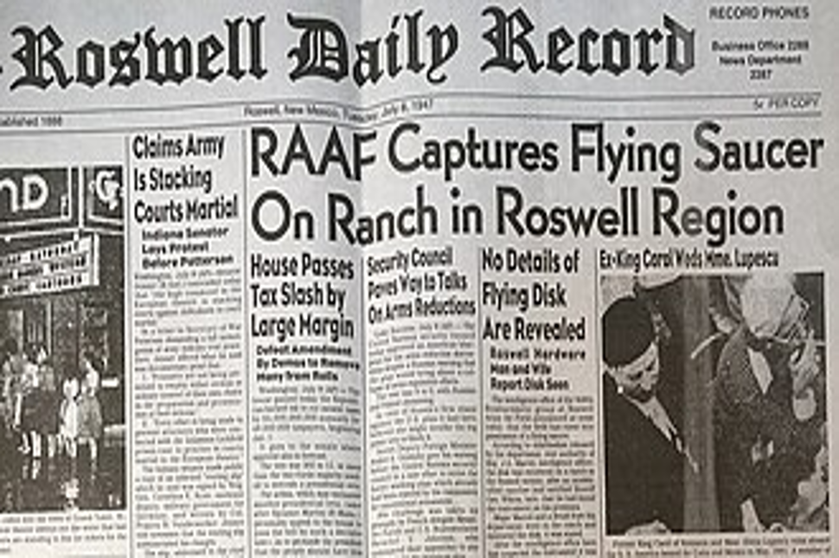

But here is a problem for the skeptics: Roswell Army Air Field was not a random outpost. As noted previously, it was associated with the 509th Bomb Group, a highly significant unit in the immediate postwar nuclear era. This drastically undercuts the notion that the local military base press unit got ahead of themselves. If a strange crash was recovered by personnel connected to the atomic-bomb-capable military establishment, why would they use the specific words “flying saucer” unless what they saw was, in fact, a flying saucer? This was the only unit in the world that had the capability to deliver an atom bomb. Is it reasonable to believe they would have made such a seemingly ridiculous mistake as failing to distinguish a UFO from a downed weather balloon? On the contrary, the 509th was exactly the type of unit that would have known they were dealing with something exotic and would realize this event might be the type that would trigger an enormous level of secrecy.
After the Roswell announcement, material was taken to Fort Worth, where Gen. Ramey displayed debris to reporters and identified it as balloon-related. This is where the famous photographs of Marcel with foil-like wreckage come from. Skeptics argue that the photographs show ordinary-looking foil, sticks, and radar-reflector material. Believers argue that Marcel later said the photographed debris was not the real material recovered from the ranch, and that the displayed wreckage was substituted as part of a cover story.
The GAO’s 1995 review found that a July 1947 history report by the 509th Bomb Group/RAAF stated that the “flying disc” in the 509th’s possession “turned out to be a radar tracking balloon.” It also found an FBI teletype from July 8, 1947, stating that the military had reported recovering an object resembling a high-altitude weather balloon with a radar reflector.
That is one of the strongest points for the skeptical side: the surviving contemporaneous records point toward balloon/radar-reflector debris, not a craft or bodies.
The believers, however, rest less on one document and more on a pattern: the military first said “flying disc,” then quickly reversed itself; the object was recovered by a significant military unit; some records later turned out to be missing or destroyed; and key participants, especially Jesse Marcel, later said the weather-balloon explanation was not true.
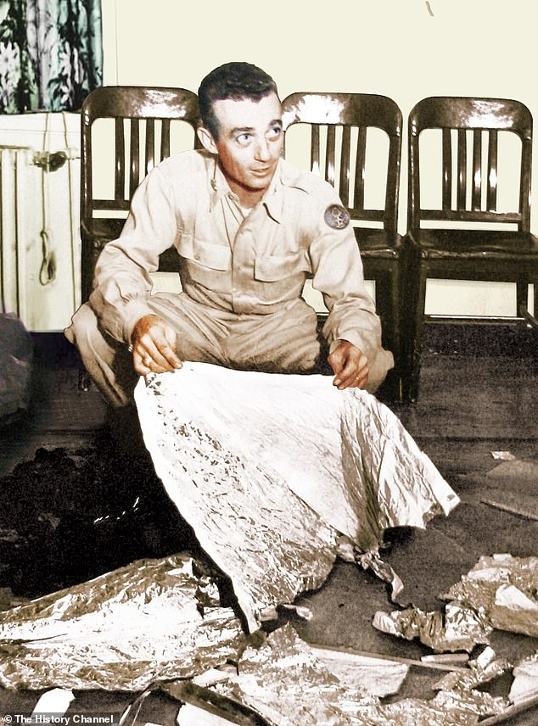
Marcel’s later role is central. The story had largely faded until the late 1970s, when Marcel spoke with UFO researchers and said the material was not a weather balloon and that the official explanation had been a cover story. TIME summarized the modern revival this way: the Air Force’s later investigation disclosed a classified balloon-tracking project as the official explanation, but some figures, including Walter Haut, continued to believe the event involved an alien landing.
There is also the issue of record destruction. The GAO found that some RAAF administrative records from March 1945 through December 1949 and outgoing messages from October 1946 through December 1949 had been destroyed, and the document-disposition form did not show who destroyed them, when, or under what authority. Could this possibly reflect messy mid-century records practices? Perhaps. But for those doubting the Air Force’s version of events, it looks like exactly the kind of gap one would expect in a cover-up.
What about the Wright-Patterson Air Field rumors
Wright-Patterson is where Roswell shifts from a New Mexico debris-recovery story into the larger “where did the material go?” crash-retrieval narrative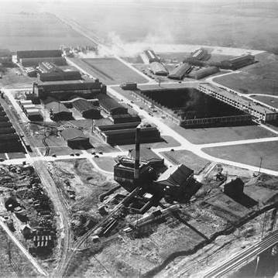
Wright-Patterson fits into Roswell in three different ways: one documented, one logical/institutional, and one highly disputed.
First, a naming note: in July 1947, it was generally referred to as Wright Field in Dayton, Ohio. “Wright-Patterson Air Force Base” became the combined name in January 1948, after Wright Field and Patterson Field were merged under the new U.S. Air Force.
1. The documented part: Roswell debris was reportedly headed to Wright Field
The most direct connection is the July 8, 1947 FBI teletype. According to the GAO’s 1995 review, the FBI message said the recovered Roswell object was described to the FBI as a hexagonal-shaped disc suspended from a large balloon by cable, and that the disc and balloon were being sent to Wright Field, now Wright-Patterson AFB, for examination. The same message said the object resembled a high-altitude weather balloon with a radar reflector.
So, no matter how skeptical one might be, Wright Field is not some random later addition. It appears in a contemporaneous 1947 government message as the likely destination for technical examination of the recovered material.
2. Why Wright Field made sense
Wright Field was the Army Air Forces’ major technical/intelligence and materiel-analysis center. The Air Force’s own Roswell report notes that Wright Field housed T-2, later known as the Air Technical Intelligence Center, and was part of the Air Materiel Command structure. In plain English: this was exactly the sort of place where unusual aircraft parts, foreign technology, experimental material, or mysterious debris would plausibly be sent.
That is why Wright-Patterson became so important in Roswell lore. If something exotic had been recovered at Roswell, Wright Field would have been the logical place to send it for analysis, reverse engineering, and compartmentalized storage.
3. Wright-Patterson as the “real destination”
In many Roswell crash-retrieval narratives, the story goes something like this: debris and possibly bodies are recovered near Roswell, first processed through Roswell Army Air Field and Fort Worth, then shipped onward to Wright Field. The Air Force’s Roswell report itself acknowledges that most Roswell stories involving alleged alien bodies have them being shipped to Wright Field.
There are certainly compelling reasons to believe that Wright Field was the real and ultimate destination. First, Wright Field had the technical capability to study unknown material. Second, the FBI teletype gives at least some documentary basis for debris being routed there. Third, Wright-Patterson later became the headquarters of official Air Force UFO investigations, which makes it feel like the natural institutional home for whatever the government knew.
There are also later witness claims, including statements about crates, lightweight material, and material allegedly transferred from Fort Worth to another aircraft headed for Wright Field. The Air Force report quotes one such claim from B-29 flight engineer Robert Porter, who said he helped fly packages from Roswell to Fort Worth and was told they were going on to Wright Field. The report includes that testimony but treats it as part of the later witness record, not as confirmed proof of extraterrestrial material.

4. The skeptical version: Wright Field received balloon-related debris, if anything
The skeptical interpretation is more straightforward: Wright Field was mentioned because the military sought technical confirmation of balloon- or radar-reflector debris, possibly connected to classified balloon work. The GAO found two 1947 records: the 509th/RAAF history stating that the “flying disc” turned out to be a radar-tracking balloon, and the FBI teletype describing a balloon/radar-reflector-like object sent to Wright Field.
The GAO then looked for Air Materiel Command/Wright Field records from 1947–1950 documenting the examination of Roswell debris and found no records mentioning the Roswell crash or the examination of debris by Air Materiel Command personnel. For skeptics, that weakens the idea of a documented crash-retrieval program at Wright Field. For believers, the lack of records is either unsurprising, given that the matter would have been highly compartmentalized, or suspicious, given that some Roswell-era records were destroyed or missing.
Of course, as we know, Wright-Patterson would soon become central to official UFO history. The National Archives states that the Air Force’s UFO investigations were headquartered at Wright-Patterson and included Project Sign, beginning in December 1947; Project Grudge, ending in August 1949; and Project Blue Book, running from March 1952 to December 1969.
The National Archives also notes that Project Blue Book ultimately logged 12,618 sightings, of which 701 remained unidentified, and that the project was headquartered at Wright-Patterson.
What may have been taken from Roswell to Wright-Patterson Air Field may forever be shrouded in mystery. But no matter what, Roswell and Wright-Patterson became linked in the broader narrative: Roswell is the alleged crash-retrieval case, while Wright-Patterson is the official Air Force hub for analyzing aerial phenomena.
Was there more than one crash site?
The Roswell event is replete with legends, stories, speculation, and much more. One of the more heavily debated topics is whether there may have been more than one crash site.
1. Corona vs. Roswell: the basic geography
The best-known recovery location was not actually in Roswell. The debris was reportedly found on the Foster/Brazel ranch, northwest of Roswell and much closer to Corona, New Mexico. The Bureau of Land Management identifies an “alleged UFO Skip Site” near Corona and describes it as a place where some believe an object crashed in July 1947; its directions place it about 78 miles from Roswell.
TIME’s summary of the original story is consistent with this: Mac Brazel found strange material on a sheep ranch northwest of Roswell, including rubber, wood, foil, tape, and paper; the sheriff contacted Roswell Army Air Field, which sent Major Jesse Marcel to investigate.
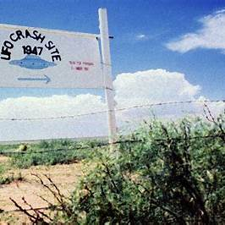
2. Were there two crash sites?
The “official” answer? No, not in any well-documented contemporaneous sense. The official story centers on one debris recovery, later explained by the Air Force as debris from the classified balloon-borne Project Mogul program. More on that later. But the Air Force’s Roswell Report says the Army Air Forces recovered debris from a balloon-borne research project code-named Mogul, and the later body stories were likely conflations with later balloon/dummy recoveries and aircraft accidents.
However, many believers, researchers, and Roswell accounts do describe more than one site. Usually the distinction is:
- The debris field near Corona/Foster Ranch — where Brazel found scattered material.
- A separate “impact” or “craft/body” site — described in later witness accounts as the place where a more intact craft and bodies were allegedly recovered.
This is where things get messy. Different authors and witnesses placed the second site in different areas. Friedman and Berliner’s Crash at Corona argued for two saucers, one near Corona and another tied to the Plains of San Agustin/Barney Barnett story. Later, Randle and Schmitt moved away from that version and introduced other alleged witnesses, including Frank Kaufmann and Jim Ragsdale, who placed craft/body recoveries elsewhere, including a site roughly north of Roswell. TIME summarized those shifting claims as part of the later Roswell literature.
So, again, there is no clear-cut answer, and even those who feel there was a second crash site do not necessarily agree on its location. But even if there was just one crash site, there is a subgenre of query and speculation to address.
Was the crash a mid-air explosion and resulting debris field, or did an object impact the ground?
Another hotly debated question is whether any object, whether it was a UFO, a weather balloon, or a secret government project, actually made contact with the ground. We know, for certain, that there was a debris field. But over the years, a theory has emerged that there might have been a debris field AND an impact crater of some sort.
1. The earliest version: scattered debris, not a clear crater
The strongest contemporaneous version centers on Mac Brazel finding scattered material on the Foster Ranch, northwest of Roswell and closer to Corona. The early descriptions emphasize rubber, a foil-like material, sticks, tape, and paper spread over a ground area. TIME’s 1997 retrospective describes the wreckage as strewn over about a 200-yard swath, while the July 1947 newspaper accounts, summarized by skeptics, also emphasized small, lightweight materials rather than engines, wrecked machinery, or a deep impact scar.
That matters because a debris field is consistent with several possible scenarios: a balloon train breaking apart, a fragile object coming down in pieces, an airborne breakup, or a damaged craft shedding material before a final impact elsewhere.
2. The “exploded in the air” version
The “exploded in the air” framing seems to become much more prominent in the later Marcel/Friedman-era revival of the story. Jesse Marcel’s late-1970s/early-1980s testimony helped revive Roswell, and a 1980 National Enquirer article was literally framed around the idea that he had picked up wreckage from a UFO that “exploded over” the United States. The late, great Stanton Friedman also argued that a flying saucer had exploded, which helped turn the scattered debris field into an airborne-breakup narrative.
From a believer’s standpoint, that model solves a problem: it explains why Brazel found many fragments over a wide area rather than a single intact saucer in a field. It also allows for a two-stage sequence: object damaged in flight → debris rains down near Corona/Foster Ranch → main body continues or crashes elsewhere.
From a skeptical standpoint, though, that is also where the story begins to diverge from the best 1947 documentation. The GAO found only two recovered 1947 government records on Roswell: one said the “flying disc” was later determined to be a radar-tracking balloon, and the FBI message described an object resembling a high-altitude weather balloon with a radar reflector. But as noted earlier, several documents that would likely shed light on the whole subject have conveniently gone missing.
3. The impact crater/gouge version
The gouge-or-impact-scar story is more commonly associated with later Roswell lore, especially accounts that describe an actual craft hitting the ground, skipping, or carving into the earth. This is where the “UFO Skip Site” language comes in. The Bureau of Land Management identifies an “Alleged UFO Skip Site” near Corona, where some believe an unidentified object containing aliens crashed in July 1947.
This version is more dramatic and more useful to the crash-retrieval narrative because it suggests a physical craft rather than just scattered lightweight debris. It also helps support the later idea of multiple locations: one area where debris was found, and another where the main craft or bodies were allegedly recovered.
But the physical evidence for a gouge is suspect. In 2002, the Maxwell Museum’s Office of Contract Archaeology conducted archaeological and geophysical testing at the reported Foster Ranch impact location. Their final report found no clear evidence of a UFO crash or military activity, though it left open the possibility that further trenching or remote sensing might test for a buried furrow. Conversely, in the Sci Fi Network’s UFO The Roswell Crash Startling New Evidence documentary, a similar archaeological study suggested that there had been a soil disturbance at a site believed to be where an alien craft impacted the New Mexico desert. So, yet again, we are left with more questions than answers.
4. Reconciling the two versions
Believers usually reconcile the two accounts by treating them as parts of the same event:
- The craft was damaged by lightning, malfunction, collision, or weapons fire.
- It broke apart in the air, creating the debris field on the Foster/Brazel ranch.
- The main body continued onward or came down separately, producing a gouge, crater, or “skip” site.
- The military recovered both ordinary-looking debris and more sensitive material elsewhere.
That is internally coherent as a story. It explains why there would be both a scattered debris field and a more dramatic impact site. The problem is evidentiary: each added step depends more heavily on later witness testimony and less on 1947 records.
5. How skeptics interpret the split
Skeptics would say the split is a sign of myth growth. In that view, the original case was a scattered debris field from a balloon-borne classified project, later identified by the Air Force as Project Mogul. The Air Force’s 1994 report concluded that the Army Air Forces recovered debris from a balloon-borne research project code-named Mogul, and that subsequent body-recovery stories were the result of conflations and retellings.
Under that reading, the debris field is the original fact, while the crater/gouge is a later attempt to make the incident look more like a classic vehicle crash.
Were Alien Bodies Recovered at Roswell?
Of all the aspects of the Roswell event that have captured the imaginations of many, nothing comes close to the tantalizing belief that bodies of alien beings piloting the doomed craft were recovered from the site. It has been the subject of a Hollywood fascination for decades, showing up as recently as Steven Spielberg’s Disclosure Day. But is it all fantasy, or were biologics of NHI origin retrieved from the Roswell crash site(s)?
The alien-body portion of the Roswell story appears to have developed later and is not strongly supported by the 1947 record. The Air Force’s later “Case Closed” report argued that many body-related memories were likely conflations of later events, including high-altitude balloon test dummies, a 1956 KC-97 aircraft accident, and a 1959 manned balloon mishap. The Air Force contended that many of these “alien body” stories were not memories of extraterrestrials at all, but confused recollections of later Air Force programs involving high-altitude balloons, anthropomorphic test dummies, aircraft accidents, and injured personnel. In its 1997 follow-up report, the Air Force specifically argued that activities spread across the 1950s had been compressed by memory and retelling into a few days in July 1947.
AARO’s 2024 report similarly states that the Air Force did not find information indicating Roswell was a UFO event or that the U.S. government recovered aliens or extraterrestrial material. It also summarizes the Air Force position that alleged “alien bodies” in New Mexico were test dummies, and that hospital body stories likely conflated later accidents and balloon mishaps with the 1947 Roswell story.
But, like many aspects of the “official story”, there are massive holes in the rhetoric. There was always a major point of pushback: the realistic test dummies most often associated with the official explanation were not part of the July 1947 Roswell event. The Air Force’s own timeline places the more advanced “Sierra Sam” and Alderson-type anthropomorphic dummies in the 1950s. Perhaps these dummies contributed to later confusion involving subsequent cases. But it does not cleanly explain the accounts of witnesses who claimed they were describing events at Roswell Army Air Field in July 1947.
Probably the most important of these witnesses was Glenn Dennis, a young mortician working in Roswell at the time. Dennis claimed that he received calls from the base asking about child-sized caskets and how to preserve bodies that had been exposed to the elements. He also claimed that when he later went to the base hospital, he saw military ambulances and strange wreckage, including material bearing unusual symbols or markings that sounded eerily similar to those Jesse Marcel saw on that small beam. According to Dennis, a frightened nurse he knew later told him that she had seen doctors performing preliminary autopsies on small, badly damaged bodies, and that the bodies were eventually taken away, possibly to Wright Field. According to Dennis, that frightened nurse was later transferred and then reportedly died in a plane crash shortly thereafter.
For believers of the alien recovery theory, Dennis is important because his account places the alleged body-recovery story not out in the desert, but inside the base hospital system, with specific references to caskets, embalming, medical personnel, noxious fumes (similar to the 1996 Varginha, Brazil event), and military intimidation of civilian witnesses.
For skeptics, however, Dennis’ story has serious problems. The Air Force concluded that his account was undocumented and uncorroborated, first reported more than forty years after the event, and that the “missing nurse” he described could not be verified in the Roswell hospital records. The Air Force also argued that some details in his story may have been confused with later real-world events, including a 1956 KC-97 crash and a 1959 balloon mishap.
So Dennis’ testimony is one of those classic Roswell pieces: dramatic, memorable, and potentially significant if true, but also difficult to verify. It does not prove alien bodies were recovered. But it does show why many researchers believe the body claims cannot be dismissed with a simple “they were just crash-test dummies” explanation.
Over the years, many others have subscribed to the belief that alien bodies were recovered from Roswell, including former astronauts Edgar Mitchell and Gordon Cooper, as well as Stanton Friedman. Will we ever know the truth? That is hard to tell, but it seems unlikely. This is unfortunate because while not everything is known about Roswell, if the alien bodies story is true, it changes, well, everything.
Was Roswell an isolated event or part of a much bigger UFO event in June and July of 1947?
When we covered the Kenneth Arnold sighting in Part 1 of the Summer of ’47 discussion, we also discussed two other key events: United Airlines Flight 105 and the Maury Island event. Those events, as monumental as they were, seemed to be parts of a larger picture rather than the picture itself. The Roswell incident might be the most famous event of June and July of 1947, rivaled only by the Kenneth Arnold sighting. But similar to the Arnold sighting, it was far from the only UFO-related event during this rather narrow time frame. Stories of flying saucers were popping up everywhere. In fact, this is one of the skeptics' strongest contentions: namely, that what people thought they saw at Roswell was heavily influenced by the saucer-mania that was ubiquitous during this time frame. It is a valid contention and one that cannot simply be dismissed out of hand.
However, there were three significant events that also occurred around the same time as Roswell. All of them happened in the Western US, not terribly far from Roswell. Given the time frames involved for these events, one has to wonder whether there may have been a sort of search-and-rescue operation going on by NHI to try and recover their crashed vehicles and colleagues before they were swooped up by the US military. Is it highly speculative? Absolutely. But it is worth considering all the same.
- July 7, 1947 near Fort Bragg, California
In Richard Dolan’s excellent book A History of USOS, Volume 1, he discusses an event that took place in the Pacific Ocean near Fort Bragg, California. Two witnesses were surf fishing on the water. At about 3:10 pm, they noticed a flat, glistening object moving towards them from out over the ocean. They indicated that the object was falling rapidly and hit the water with a massive splash about a quarter of a mile offshore. A humming sound was noticed just before the object hit the ocean. The object floated for a short amount of time and then disappeared. The witnesses thought the object was round, but they could not be sure. However, the fact that the object floated for a bit before presumably sinking likely rules out a meteor or a similar natural object. Dolan gave this event an evidence rating of 8/12, categorizing it as solid.
If the Roswell crash occurred on July 2, 1947, was this object an example of another crash occurring several days later, roughly 1,400 miles to the west? If this was another crash, then why? Lighting was not involved in this event, which raises questions as to what might have been going on.
Approximately 500 miles to the east, a much more involved and well-documented event was about to take place.
- July 8, 1947, Muroc Army Air Field (Later known as Edwards AFB)
As Roswell was about to become part of Americana with the famous article announcing the recovery of a flying saucer, another startling event was unfolding in California’s Mojave Desert. Roswell was publicly announced on July 8 when Roswell Army Air Field said it had recovered a “flying disc,” while the Muroc witnesses were reporting disc-like objects over or near one of the country’s most important test facilities
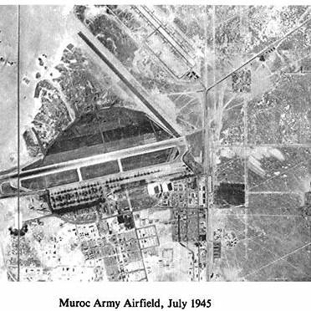
The surviving Muroc material includes investigative documents from the Fourth Air Force/Muroc Army Air Field. On August 14, 1947, Muroc’s intelligence officer forwarded multiple witness statements concerning “flying discs.” The final case synopsis said that on July 8, around 1000 hours, “two incidents” occurred near Muroc Flight Test Base, and that no further investigation was being considered by that headquarters.
The strongest cluster begins around 9:30–10:00 a.m. First Lt. Joseph C. McHenry, the billeting officer, said he saw two silver objects, either spherical or disc-like, moving at roughly 300 mph or less at an altitude of about 8,000 feet. He called several others outside, including S/Sgt. Gerald Nauman, T/Sgt. Joseph Ruvolo and Jannette Marie Scott also reported seeing the objects. McHenry specifically said they were neither aircraft nor weather balloons, partly because of their speed and direction relative to the prevailing wind.
A few minutes later, McHenry and others reported a third object, also silver and spherical or disc-like, making tight circular movements over the north end of the base. This is one of the more interesting parts of the case because the witnesses described maneuvering, not just a bright object drifting across the sky. Scott’s statement likewise described two silver disc-like objects flying toward Mojave, followed shortly by another similar object flying in a tight circle at about the same altitude.
Around 11:50 a.m., Capt. John Paul Strapp was in an observation truck at Rogers Dry Lake for a P-82 ejection-seat experiment. He and others saw a rounded, white-aluminum-colored object that at first looked like a parachute canopy. But according to his statement, it descended faster than the actual test parachute, drifted against the prevailing wind, showed an oval outline with two projections on top, and displayed no smoke, flame, propeller arcs, engine noise, or obvious propulsion. Importantly, Strapp’s own opinion was that the object was probably man-made, possibly dropped from a great height.
There was also a statement from Major Richard R. Shoop, who said that around noon his attention was called to a thin metallic object north of the base. He described it as reflecting sunlight, oscillating, descending almost to the ground, then climbing and moving off. He estimated it was visible for about eight minutes and roughly the size of a pursuit aircraft, though not shaped like a conventional plane.
There is one wrinkle: Major J.C. Wise, a test pilot, gave a statement describing an object he saw while he was running up an XP-84, but it lists the date as July 7, not July 8. Later summaries, including Edward Ruppelt’s account, fold this into the July 8 Muroc sequence. So there is a minor date ambiguity in the record. Wise described a yellowish-white spherical object, perhaps 5–10 feet in diameter, moving about 200–225 mph and not behaving like a weather balloon.
From a pro-UFO perspective, Muroc is compelling because this was not a random civilian report. These were military personnel, test pilots, technicians, and base personnel at a flight-test center. Several witnesses were familiar with aircraft and balloons, and some specifically tried to rule out aircraft, birds, balloons, eye strain, and optical illusion. The objects were described as metallic or silver, disc-like or spherical, moving against wind, maneuvering, or oscillating.
Edward Ruppelt, who later headed Project Blue Book, wrote that, according to older Air Technical Intelligence Center personnel, the Muroc case was the first sighting to make the Air Force take a deep interest in UFOs. He also placed it within a broader pattern of early reports near sensitive locations such as Muroc, White Sands, and atomic facilities.
This, therefore, supports a theory that I have: Roswell was not happening in isolation. On the same day Roswell entered the newspapers, credible military personnel at Muroc were reporting unusual aerial objects over a sensitive test range. Keep in mind that some of the rumors about Roswell suggest that the wreckage and bodies were not taken to Wright Airfield, but may have been sent to Muroc instead. If that is true, was this a search-and-rescue attempt being made by NHI? In theory, Muroc is the better-documented of the two events, the obvious massive difference being that, at Muroc, there was no crash and no bodies.
Now the skeptics have their points to make about this event, and some of them are solid. Muroc was an experimental flight-test base. If unusual objects were going to be misidentified anywhere, a test range full of aircraft, parachute tests, balloons, ejection-seat experiments, and classified hardware is a good candidate.
Second, not all witnesses interpreted the objects as exotic. Strapp specifically thought the 11:50 object was probably man-made. Col. Gilkey, according to the file, apparently thought what he saw might have been paper and not significant enough to report in detail.
Lastly, there was no crash, no recovery, no radar confirmation, no photographs, and no physical evidence tied to the Muroc sightings.
Still, Muroc is somewhat of a forgotten event that was, understandably, overshadowed by the events taking place approximately 900 miles to the east.
- The Rhodes UFO Photos
On July 9, 1947, as Roswell was exploding across the National Press, an article and photographs appeared in the Arizona Republic. William A. Rhodes described an unusual object over Phoenix (50 years before the Phoenix Lights event) in the late afternoon of July 7. In later case summaries, the object is described as elliptical, flat, and gray, descending or spiraling from roughly 5,000 feet to 2,000 feet, then climbing away at an angle. Rhodes took two photographs. NICAP’s case directory summarizes the estimated speed as 400–600 mph, the estimated size as 20–30 feet, and notes that Project Sign later treated it as Incident No. 40.
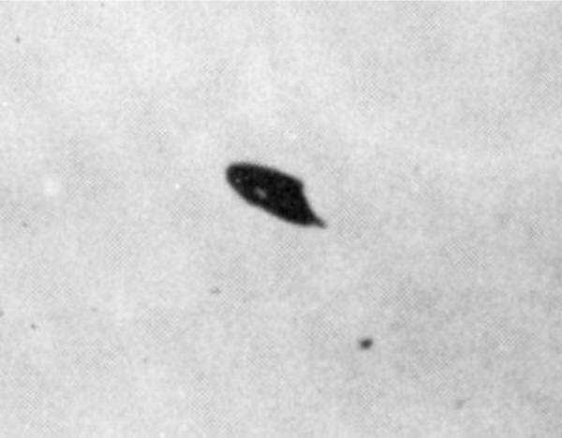
The photos are sometimes called the “shoe-heel UFO photographs” because the object does not look like the later Hollywood flying saucer. It has a rounded/elliptical body with a sort of clipped or tail-like end. That odd shape is part of what makes the case interesting.
This is another example of how the Southwest was alive with “flying disc” reports at almost the exact same moment Roswell entered the news. The Debrief’s review of the case notes that Rhodes’ sighting occurred in the same media environment as Kenneth Arnold, Roswell, and the broader flying saucer wave, and that government officials quickly became interested in the photographs. The Rhodes case also has something Roswell does not: actual photographs from the same narrow window of time. If one is arguing that Roswell was part of a broader aerial event, Rhodes becomes one of the better visual companion cases.
One of the more interesting parts is that the Rhodes object arguably resembles Kenneth Arnold’s original description more than the classic saucer shape. Arnold did not describe simple dinner-plate discs; in some depictions, his objects were more crescent-like or heel-shaped. The Debrief notes that government investigators later observed a similarity between the Rhodes photos and Arnold-related drawings, treating that resemblance as significant in the early investigation.
And, of course, it would not be an early UFO-related event if we did not have some key pieces of evidence go missing. This is where the case takes on a very Roswell-like tone. Rhodes reportedly turned over prints and/or negatives to government representatives, and later questions arose about whether the originals were returned. The Debrief’s review of archived documents says investigators looked closely at the photographs, Rhodes himself, his background, and the chain of possession. It also notes that by 1952 there was internal concern over where the negatives were and whether they should be returned to Rhodes “with apologies” if found.
Yet again, a potentially important piece of original evidence enters government hands, is analyzed, and later its location or return becomes disputed. This echoes Roswell’s missing-records problem and the Battle of Los Angeles photo/negative problem — not as proof, but as another trust-eroding evidentiary gap.
The skeptical take on the Rhodes UFO photos is understandable. The photographs are ambiguous. Without reliable distance, size, and independent corroboration, a small object close to the camera can appear larger in the sky. Rhodes also had interests in radio, photography, and model aircraft, which skeptics sometimes cite as evidence that he had the technical ability to stage something. Later investigative records included both serious interest and suspicion; one summary notes that the case files included both the possibility of a hoax and more favorable evaluations. Other explanations suggest that the photos show paper kicked up by the wind and photographed.
Skeptics also note that intense government interest does not necessarily equal alien significance. In July 1947, the military was worried about Soviet technology, experimental aircraft, public panic, hoaxes, and intelligence leaks. The National Archives notes that the flood of post-Arnold UFO reports led the Air Force to create Project Sign later that year to collect and evaluate sightings that could pose national security concerns.
So, was there a good reason for the government to take a strong interest in anything that could be remotely considered a threat to national security? Absolutely. But that does not mean that events like Fort Bragg, Muroc, Phoenix, or Roswell can all be swept away as systematically as the government, or the skeptics, would like.

Project Mogul
As is well known, the government's official explanation for what crashed at Roswell was simply a weather balloon. From 1947-1994, the government stuck by this story. When interest in Roswell picked up in the late 1980s, though, the government seemed to pivot to a more exotic type of weather balloon. What is undisputed, though, is that the government did, in fact, lie about what crashed at Roswell, even though skeptics will claim this is more a case of semantics than outright deceit.
By the 1990s, after congressional interest from Rep. Steven Schiff of New Mexico, the Air Force and GAO revisited Roswell. The Air Force concluded that the debris was likely from Project Mogul, a classified balloon-borne research program intended to detect Soviet nuclear tests using high-altitude balloons and acoustic sensors. The Air Force’s Roswell Report states that the Army Air Forces recovered debris from a balloon-borne project code-named MOGUL.
AARO’s 2024 historical report repeats the core official conclusion: Project Mogul operated from 1947 to 1949, sought intelligence on Soviet nuclear weapons testing and early warning of ballistic missiles, and used high-altitude balloons carrying sensors to detect long-range sound waves. AARO states that a crashed Project Mogul balloon outside Roswell is assessed to be the source of early UFO claims.
This explanation is stronger than the original “weather balloon” explanation because Mogul was not just an ordinary weather balloon. It was a classified military/intelligence program, which helps explain why personnel might have been evasive or imprecise in 1947.
One of the biggest complaints I have always had about the Project Mogul explanation is that it took the Air Force some 50 years to come up with it. Of course, I am not the only one to voice this suspicion. The Air Force’s retort to this complaint makes sense in some respects, and makes zero sense in others.
The Air Force’s 1994 report says Roswell was not really treated as a UFO event until the 1978–1980 revival, when Jesse Marcel and later UFO authors turned it into a crash-retrieval story. Before that, according to the Air Force, the matter had been dismissed as a weather-balloon incident. The 1994 Air Force inquiry began after Congressman Steven Schiff pushed for a GAO review, which triggered a systematic search of Air Force archives and records centers.
The explanation for the delay had several parts.
First, Mogul was classified and compartmented. The Air Force described Project Mogul as a sensitive classified effort to detect Soviet nuclear weapons activity using balloon-borne acoustic sensors. It said the purpose of the project was highly sensitive in the early Cold War, even though many of the physical materials — balloons, radar reflectors, sticks, foil, tape — were not exotic. In my opinion, this is a critical component: the purpose of Mogul may have been classified, but the components from which it was constructed were clearly not.
Second, the Air Force argued that very few people knew the program's full purpose. Its report says some scientists knew the real purpose but not necessarily the project name, while newly hired employees were told only that they were working with meteorological equipment. That compartmentalization, according to the Air Force, helped keep Mogul from being recognized for many years as a possible explanation for Roswell.
Third, the Air Force said the Roswell recovery quickly became a “non-event” after Gen. Ramey’s weather-balloon explanation. The report says the recovered materials were not readily recognizable as anything special, the debris itself was unclassified, and the press quickly lost interest; therefore, from the Air Force’s perspective, there was no particular reason to continue documenting it as a major incident.
That is the official logic. But there are obvious reasons many people find it unsatisfying.
The big problem is that the Air Force’s explanation effectively concedes that the original “weather balloon” story was incomplete or misleading. The Air Force said it found no documented evidence that Gen. Ramey was ordered to use a weather-balloon cover story, but it also acknowledged he may have been trying to deflect attention from Mogul, or may simply have accepted the weather officer’s identification because the material looked balloon-related.
The Project Mogul Flight No. 4 Controversy
While most people believe the Roswell crash occurred between July 2 and July 4, 1947, the Air Force’s Project Mogul explanation pushes the “came down” date back even further. The Air Force concluded that the debris most likely came from Project Mogul Flight No. 4, allegedly launched on June 4, 1947. In that version, Brazel’s debris was balloon-train material that had come down weeks earlier, and the July 8 excitement was just the point at which the debris entered public and military channels. The Air Force report also emphasizes that Brazel’s July 8 statement placed the debris discovery around June 14, about 10 days before the Kenneth Arnold sighting, which would also rule out a July crash under the official theory.
However, there is a strong reason to believe that Project Mogul Flight No. 4 never happened, or at least not as the government claimed.
The Air Force’s 1994 Roswell report concluded that the debris was “very probably” from Mogul Flight No. 4, launched from Alamogordo on June 4, 1947, and not recovered by the NYU/Mogul team. The Air Force relied heavily on Albert Crary’s journal and Charles Moore’s later analysis, saying the June 4 launch involved a cluster of meteorological balloons and a sonobuoy.
That explanation is attractive to skeptics because it accounts for several things at once: balloon-like debris, foil- or radar-reflector-type material, secrecy, confusion at Roswell Army Air Field, and the later shift from “weather balloon” to “classified balloon project.”
Critics argue, however, that Crary’s own June 4 diary entry undercuts the Air Force’s conclusion. The famous line is essentially:
“No balloon flights again on account of clouds. Flew regular sonobuoy up in cluster of balloons…”
Kevin Randle and others argue that this means the planned full Mogul flight was canceled because of cloud cover, and that what went up later was only a smaller sonobuoy test using a cluster of balloons — not a full Mogul array with the long train of balloons, radar targets, rigging, and debris-producing material needed to explain Roswell.
Skeptics respond that critics are over-reading the diary language. Their position is that something did fly on June 4, even if the terminology is messy. They argue that Crary’s entry does not prove “no launch at all”; it may mean the originally planned configuration was altered or delayed, but a balloon cluster with equipment still went up. Charles Moore, who worked on the NYU balloon launches, later maintained that Flight 4 launched and that its projected path could have taken it near the Foster Ranch area. Skeptical Inquirer’s retrospective likewise treats Moore’s account as important because he was directly involved with the balloon work.
So, again, there is no consensus. But here is something to consider. As noted before, and as is pretty much undisputed, Project Mogul was made up of common materials frequently used in less classified projects and in ordinary weather balloons. Is it reasonable to believe that military personnel affiliated with the world’s only atomic bomb unit would not have recognized the debris they encountered as prosaic and rather common? Possibly… but unlikely.
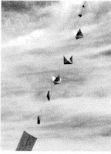
A Project Mogul sensor train
The Ramey Memo
Here is one last tidbit of information to consider. Near the end of the Sci Fi Network’s UFO The Roswell Crash Startling New Evidence documentary, a compelling piece of evidence is presented involving the so-called “Ramey Memo”. The Ramey Memo is the paper Brig. Gen. Roger Ramey was holding in the famous July 8, 1947, Fort Worth photos, taken while he displayed the alleged Roswell debris. The 2002 Houran/Randle study describes the photo as showing Ramey near the remains of a weather balloon and Rawin radar target, with a document in his hand on which some words appear visible.
The provocative claim, most famously associated with David Rudiak, is that the memo contains phrases such as “victims of the wreck” and references to a “disc.” That is the “smoking gun” claim featured in older Roswell documentary treatments and later repeated in UFO circles.
Right around the time that documentary aired, James Houran and Kevin Randle published a study called “A Message in a Bottle” in the Journal of Scientific Exploration. They had different groups of participants try to read the memo under different suggestion conditions: one group was told it related to Roswell, another was told it related to atomic testing, and another was given no specific context. Their conclusion was not that the memo was useless, but that its interpretation was highly vulnerable to expectations and suggestions.
That study is important because it undercuts the idea that one person’s claimed reading can be treated as definitive. Many participants believed they could read parts of the memo, but their readings tended to follow the contextual hints they were given. Still, a few words were perceived consistently across groups, suggesting that some portions may be genuinely legible, even if the crucial phrases remain disputed. Words like “Fort Worth TX,” “story,” and “weather balloons” were identified with some consistency. But the explosive phrases often cited by Roswell researchers — especially “victims of the wreck” — were not confirmed across the test groups. The Pro-UFO group produced Roswell-flavored words such as “remains,” “crash,” and “UFO,” while the Atomic Bomb group produced context-fitting words like “glasses,” “flash,” “atomic,” and “laboratory.” That was part of the authors’ caution: people could see real-looking words, but the words they perceived were influenced by the story they were told before looking at the image.
The study’s takeaway was not that the memo says nothing, but that it remains too ambiguous and too vulnerable to expectation bias to be used as a smoking gun.
The biggest technical update came in 2015, when Randle, Rudiak, UTA Special Collections, and photographic/forensic experts arranged another round of nondestructive scans of the original negative. Randle later wrote that the team conducted dozens of new scans under different conditions, hoping to clarify the memo sufficiently to reach consensus.
But the result was disappointing. Randle said the new techniques did not produce an immediate breakthrough, cleaned up the memo only marginally, and left the critical areas still unreadable. His bottom line at the time was: “There was no new and great revelation,” and “we are not much closer to a solution than we were.”
That is probably the most important update since the older documentary: better scans were made, but they did not settle the memo.
The current state: still disputed
Kevin Randle’s 2022 “Grounded Theory Update” states the matter plainly: attempts to decipher the Ramey memo have not yielded definitive results that would rule out any explanations, though he still considers higher-quality digital scans one of the few empirical areas where progress might be possible.
To wit, a 2025 ResearchGate preprint claimed that new proprietary imaging analysis had identified the phrase “1 P-AAF-ATC 34, VICTIMS/DISC” in the Ramey memo and argued that this confirms references to victims and a disc. If validated, that would be highly significant. But the paper is not peer-reviewed, relies on proprietary methods, and has not produced a broad expert consensus. For now, it is best treated as an interesting new pro-crash claim rather than a settled decipherment.

CONCLUSIONS
We have now come full circle. I have tried to present as much information to you as I could so that you could answer, for yourself, the enduring question of what happened at Roswell. 79 years later, we are no closer to knowing for certain than we were on July 8, 1947. Both believers and skeptics can point to strong factors and evidence to support their position. Anyone can pick one side of the debate or the other and feel quite good about the relative strength of their position. If the believers are correct, Roswell is where the Legacy UFO/Crash Retrieval Program was likely born. More importantly, if alien bodies were recovered, that would likely prove we are not alone in the universe.
For me, I tend to side with the believers. That is not to say there are not problems and holes in the story. But you can say that about the skeptical position as well. What sways me the most are the witnesses. Roswell was a town filled with military personnel, families, officers, and an elite atomic bomb unit fresh off delivering the only atomic weapons ever dropped on civilian populations. Why would so many people in a town of that sort of composition subscribe to such an elaborate and wild hoax? And even if you want to say that it was not a hoax, just a case of misidentification, we still run into the problem of some of the best military personnel in the nation, at the time, not being able to tell the difference between common weather balloon material and something that might have originated off-world. It does not make much sense.
All these years later, Roswell persists as the most famous UFO case in history. All we still know for certain is that something crashed in the New Mexico desert in July of 1947. Beyond that, it is up to you to decide what you believe and why.

