:THE LEGENDS & LORE OF ANTARCTICA
Introduction: The Continent at the End of the World
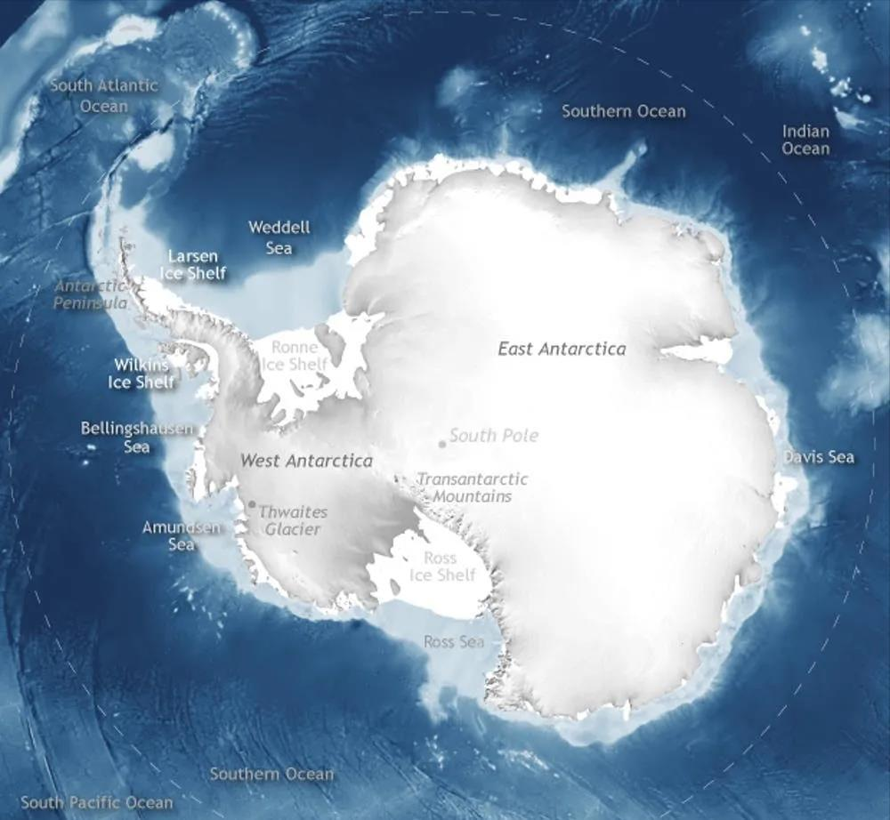
No place on Earth is better suited to the strange, mysterious, and unexplained than Antarctica.
It is enormous. It is remote. Almost the entire continent is buried beneath ice. No permanent indigenous inhabitants, no ordinary cities, no interstate highways, and very few people will ever personally explore more than a tiny fraction of it. Its history contains secret military operations, competing territorial claims, Nazi expeditions, unexplored mountain ranges, crashed aircraft, classified Cold War projects, and one of the most unusual international treaties ever negotiated.
And beneath as much as several kilometers of ice lies an entire continental landscape of mountains, valleys, lakes and geological features that human beings cannot ordinarily see.
Over the decades, stories have accumulated involving lost civilizations, ancient maps, pyramids, giants, Nazis, flying saucers, Hollow Earth entrances, underground cities, extraterrestrials, secret space programs and even hidden lands supposedly existing beyond an enormous Antarctic "ice wall."
Some of these stories have essentially no supporting evidence. Others have an intriguing fragment of genuine history buried somewhere inside them. And in several cases, the documented story is strange enough that embellishment almost seems unnecessary.
For purposes of The Legends & Lore of Antarctica, therefore, it is useful to separate the material into three loose categories:
Documented: Events, people or documents whose existence is historically established.
Contested: Genuine events or artifacts for which an unusual interpretation has subsequently been proposed.
Lore: Stories circulating primarily through occult literature, UFO culture, alternative history or conspiracy communities without much in the way of supporting evidence.
The fun begins when those three categories overlap.

I. ANTARCTICA BEFORE ANTARCTICA: THE MYSTERY OF THE ANCIENT MAPS
Documented fact: Antarctica was not confirmed by explorers until the nineteenth century.
For centuries, Europeans suspected a great southern continent existed, but nobody knew what it looked like—or even whether it existed.
Captain James Cook crossed the Antarctic Circle during his voyages of the 1770s but never saw the continent itself. The first generally recognized sightings came in 1820, involving Russian explorer Fabian Gottlieb von Bellingshausen and British naval officer Edward Bransfield. Bellingshausen observed the Antarctic ice margin on January 27, 1820; Bransfield saw continental land on January 30.
Yet strange-looking southern continents appear on maps centuries earlier. That discrepancy underpins one of the oldest Antarctic mysteries.

Terra Australis
Ancient and Renaissance geographers often believed that a great southern landmass—Terra Australis Incognita, the "Unknown Southern Land"—must exist.
This was partly philosophical. Classical geographers reasoned that the great landmasses of the Northern Hemisphere might require a comparable southern mass to "balance" the world.
So cartographers sometimes drew one.
A spectacular example is the map produced by French mathematician Oronce Fine—or Orontius Finaeus—in 1531. Fine's map contains a huge southern continent labeled Terra Australis. The Library of Congress notes that the continent bears a superficial resemblance to Antarctica while concluding that Fine probably possessed no actual knowledge of Antarctica beyond ancient and Renaissance geographical speculation.
And therein lies the mystery.
If Fine was simply guessing, parts of the map look remarkably suggestive. If he was not guessing, where did the information come from?
The Piri Reis Map
The far more famous example is the Piri Reis map of 1513.
Piri Reis was an Ottoman admiral and cartographer. His surviving map depicts portions of Europe, Africa, and South America and was compiled from numerous earlier charts.
Beginning particularly in the twentieth century, researchers including Charles Hapgood argued that the southern portion of Piri Reis's map represents the coastline of Antarctica—possibly even Antarctica without its ice sheet.
Hapgood developed the argument extensively in his 1966 book Maps of the Ancient Sea Kings. His hypothesis proposed that highly sophisticated geographical knowledge survived from an unknown civilization thousands of years older than Egypt, and that later cartographers unknowingly copied fragments of those ancient source maps.
If true, the implication is enormous. Somebody would have mapped Antarctica thousands of years before conventional history says anyone possessed the capability to do so.
Alternative-history interpretations therefore ask:
Who were these mapmakers? Atlantis? A forgotten maritime civilization? Survivors of an Ice Age civilization? Extraterrestrial visitors? Or an advanced human culture erased by some prehistoric catastrophe?
Mainstream cartographic scholarship strongly disputes the Antarctic interpretation. Gregory McIntosh's extensive scholarly study of the Piri Reis map concludes that the supposed Antarctic coastline is a distorted continuation of South America and rejects claims that the map shows knowledge from an ancient advanced civilization or extraterrestrials.
But for our purposes, the important point is that the map is genuine.
The controversy concerns what it depicts. That distinction makes the Piri Reis map much more interesting than a simple hoax.
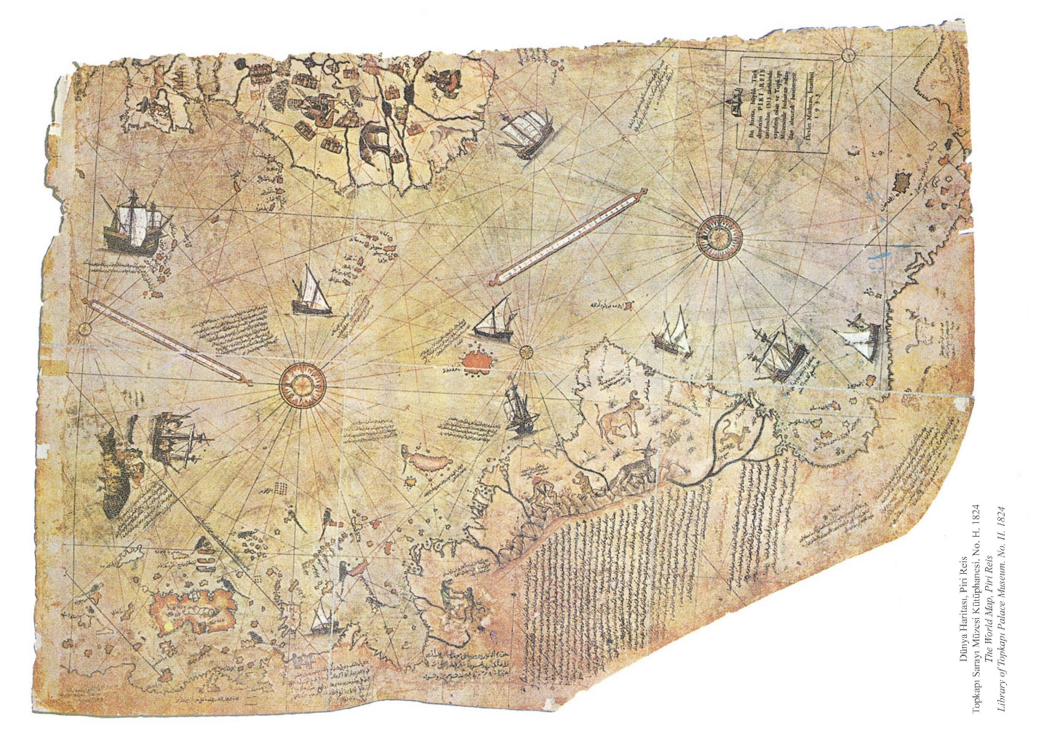
Philippe Buache
Another frequently cited example comes from French geographer Philippe Buache, whose eighteenth-century maps depicted hypothetical southern lands before Antarctica had been properly explored.
A surviving 1739 Buache map of southern territories is held by the Bibliothèque nationale de France.
Alternative researchers sometimes argue that later Buache maps appear to depict portions of an ice-free or divided Antarctic continent. Conventional cartographic historians again regard these as theoretical geographic constructions rather than inherited prehistoric surveys.
But taken together—Piri Reis, Oronce Fine, Buache and various representations of Terra Australis—they create the first major Antarctic mystery:
Why does something resembling Antarctica keep appearing on maps before Antarctica was officially discovered?

II. HITLER'S ANTARCTICA: NEUSCHWABENLAND AND BASE 211
Unlike many of the more sensational Antarctic conspiracy stories, this one begins with something absolutely real.
Nazi Germany really did send an expedition to Antarctica.
The German Antarctic Expedition of 1938–39 explored an area of Queen Maud Land that the Germans called Neuschwabenland—New Swabia.
Aircraft photographed enormous areas and dropped markers bearing swastikas.
The expedition discovered previously unknown geographical features, including the Schirmacher Oasis, an unusual ice-free region containing exposed rock and lakes.
However, according to a detailed historical investigation by Colin Summerhayes and Peter Beeching published in Polar Record, the Germans made only three brief landings on the ice shelf and built no permanent base.
One major German motivation was economic. Germany needed fats and oils and depended heavily on imported whale oil. Establishing a stronger German presence in Antarctic whaling grounds had considerable strategic value.
Then World War II began, and the expedition abruptly became fertile ground for legend.
Base 211
One version of events is that the Nazis were not simply surveying Antarctica; They were preparing a refuge. The supposed installation eventually became known as Base 211 or Station 211.
Different versions describe it as:
- a hidden underground military complex;
- a submarine base beneath the Antarctic ice;
- a research facility where advanced aircraft were developed;
- a refuge for senior Nazi officials;
- an occult installation connected with the Thule or Vril societies;
- or eventually the headquarters of a postwar Nazi breakaway civilization.
Then came one of those historical coincidences that mythology absolutely loves. Germany surrendered in May 1945. Yet two German submarines—U-530 and U-977—subsequently surrendered in Argentina months later. Where had they been? The Antarctic explanation was irresistible. Rumors emerged that submarines had carried Hitler, senior Nazis, treasure, exotic technology or scientists to Antarctica.
The extensive Summerhayes/Beeching investigation examined these stories and concluded that the submarines' known capabilities, movements and timelines do not support the Antarctic scenario and that no evidence establishes a wartime German base in Antarctica.
But that did not kill the story. It merely created the next chapter. Because about a year later, the United States Navy arrived in Antarctica with a force so large it looked more like an invasion than a scientific expedition.
OPERATION TABARIN: THE SECRET BRITISH ANTARCTIC MISSION
In 1943, while World War II was still raging, the British government organized Operation Tabarin, a secret Antarctic operation involving the Admiralty and Colonial Office.
The British Antarctic Survey itself describes Tabarin as a top-secret wartime mission. Its objectives included preventing enemy ships from using Antarctic harbors, collecting weather information useful to Allied shipping, and reinforcing British territorial claims. Beginning in 1944, Britain established permanent bases at locations including Deception Island, Port Lockroy, and later Hope Bay.
These objectives are not mysterious in the context of World War II. But they add an extremely interesting piece to the Antarctic mythology.
During precisely the period when legend says Nazi Germany was attempting to maintain an Antarctic presence, Britain genuinely was conducting a secret wartime operation in Antarctica partly intended to prevent enemy ships from operating there.
That does not prove that British intelligence knew about Base 211. But it does demonstrate something useful when discussing the larger legend:
Governments really were concerned about enemy activity in Antarctic waters, and they really did conduct secret missions there.
THE VRIL SOCIETY, THULE AND THE NAZI FLYING SAUCERS
This may be the most entertaining rabbit hole of all, and it ties directly into Base 211 and the persistent rumors about Nazi’s, aliens, and Antarctica.
A Thule Society genuinely existed in post-World War I Germany, and historians have documented connections between elements of the Thule milieu and the early Nazi movement.
Historian Eric Kurlander has shown that early National Socialism operated within a broader German environment fascinated by subjects including Nordic mythology, Germanic paganism, ariosophy, occult doctrines, and various forms of what might today be called fringe science. Nazi attitudes toward occultism were complicated—some occult organizations were eventually suppressed—but the underlying fascination with mystical racial histories, Atlantis, and unconventional science was real.
Then we get to Vril.
The word originally comes from Edward Bulwer-Lytton's 1871 science-fiction novel The Coming Race, in which an advanced subterranean civilization possesses an extraordinary energy called Vril.
Notice what we already have:
An advanced civilization living beneath the surface of the Earth. Decades later, German esoteric circles absorbed the concept. And after World War II, the story became considerably more elaborate. The later mythology describes a Vril Society, sometimes portrayed as a secret occult organization operating alongside or in cooperation with the Thule Society.
Eventually another remarkable character enters the story:
Maria Orsic. According to later accounts, Orsic was a beautiful female medium whose extraordinarily long hair supposedly functioned almost like an antenna for telepathic communication. During séances, she and other Vril mediums allegedly received messages from beings associated with the star Aldebaran, roughly 65 light-years from Earth. And those messages supposedly contained something extraordinary:
Technical information for constructing advanced flying machines. From here emerge the legendary Vril and Haunebu flying discs.
The most spectacular versions describe circular craft using exotic propulsion systems capable of phenomenal speeds—and eventually interplanetary or even interdimensional travel. Some claimed Haunebu designs grew into enormous craft, while other stories describe cigar-shaped "mother ships" that could carry smaller flying discs.
Historian Nicholas Goodrick-Clarke examined this material extensively in Black Sun: Aryan Cults, Esoteric Nazism and the Politics of Identity. He traced much of the elaborate Vril/Aldebaran/Antarctic mythology to postwar esoteric and neo-Nazi literature rather than authenticated wartime German documentation. Later presentations deliberately blurred staged imagery, speculative stories, and archival material to create the appearance of a historical documentary record.
A recent academic examination of the history of the Vril concept similarly notes how postwar literature transformed Vril into the supposed technological foundation for Nazi secret weapons and stories in which Nazi elites escaped to hidden bases beneath the polar regions.
So, no concrete evidence establishes the existence of an operational Haunebu fleet. But consider how perfectly the legend solves the problems the Base 211 story creates.
How did the Nazis reach Antarctica? Submarines. How did the Antarctic colony survive? Advanced technology. What mysterious aircraft were supposedly encountered during Operation Highjump? Haunebu flying discs. Where did the technology come from? Vril. Where did Vril come from? Extraterrestrial communications.
Suddenly, the Nazi Antarctic story isn't merely about an escaped military force. It becomes the origin story of a technologically independent civilization. And once the extraterrestrial element enters the story, practically anything becomes possible.

III. OPERATION HIGHJUMP: WHAT WAS THE U.S. NAVY REALLY DOING?
In late 1946, the United States launched Operation Highjump, officially the United States Navy Antarctic Developments Program. It remains the key event fueling the more sensational and fascinating aspects of Antarctica lore.
Highjump involved roughly 4,700 personnel, 13 ships, aircraft, helicopters, an aircraft carrier, a submarine, and icebreakers. It was by far the largest Antarctic expedition attempted up to that time. Rear Admiral Richard E. Byrd, already one of the most famous polar explorers in history, served as officer in charge, while Rear Admiral Richard Cruzen commanded the task force.
The officially stated objectives included:
- training personnel in extreme cold;
- testing ships and equipment;
- establishing and operating an Antarctic base;
- aerial photography and mapping;
- determining the practicality of maintaining bases in polar conditions;
- and gathering scientific information.
These objectives make perfect strategic sense in the immediate aftermath of World War II and at the beginning of tensions with the Soviet Union.
But Highjump contains several details that have fueled speculation ever since.
It was enormous! You do not need 4,700 men and an aircraft carrier to send a handful of scientists to look at penguins. That does not mean the United States was attacking Nazis, but the sheer military scale makes the operation visually and rhetorically perfect for that interpretation.
It was supposed to last longer! National Archives material describes Highjump as expected to operate for about six to eight months. Yet the principal Antarctic operations ended much sooner. Why? The conventional explanation is worsening conditions and approaching winter. The ice became increasingly dangerous. Ships suffered damage. One vessel required towing. Cruzen and Byrd ultimately accelerated evacuation because rapidly thickening pack ice threatened to trap vessels at the Bay of Whales.
Brad Olsen, author of the excellent book Secrets of Antarctica: The Untold History of the Ice Continent, which played a massive role in the research that forms the backbone of this research project, has described Highjump as being terminated roughly two months into what had been projected as a six-to-eight-month expedition. That six-to-eight-month figure does appear in National Archives descriptions of the overall mission. But the Navy’s own records show that the Antarctic field season was never expected to continue through the southern winter. Most elements departed roughly when seasonal conditions dictated, although the Little America group was indeed evacuated several weeks earlier than anticipated because of worsening pack ice.
There were also genuine fatalities. On December 30, 1946, the PBM Mariner flying boat George 1 crashed during a blizzard, killing three crewmen. Six survivors endured nearly two weeks before being rescued. Another sailor, Vance Woodall, died in an equipment accident.
Those are documented tragedies. The later legend transforms them into battle casualties.
The alternative version: The Battle of Antarctica
In its most sensational form, Operation Highjump was not primarily a scientific expedition. The United States supposedly knew that remnants of Nazi Germany had established themselves beneath Antarctica. Highjump was sent to remove them.
According to later accounts, American forces encountered advanced disc-shaped aircraft—sometimes called Flügelrads—capable of astonishing acceleration and maneuverability. These craft supposedly attacked the American task force. Aircraft were destroyed. Ships were damaged. The operation was abandoned.
And the United States government buried the entire event. No reliable historical documentation shows this battle occurred. But one authentic Byrd quotation keeps the mythology alive.
The Byrd warning
After Highjump, journalist Lee van Atta interviewed Byrd. The interview appeared in the Chilean newspaper El Mercurio on March 5, 1947. Byrd warned that the United States needed protection against a possible attack by hostile aircraft approaching through the polar regions.
That statement is real.
Online, it is often transformed into something far more dramatic: Byrd supposedly warned about flying objects that could travel "from pole to pole at incredible speeds." The actual statement fits perfectly well within emerging postwar strategic thinking. Long-range bombers approaching North America through polar routes were becoming an obvious national-security concern. But place Byrd's statement immediately after an unexpectedly shortened Antarctic military expedition, add stories of Nazi flying saucers, and its meaning changes considerably.
That ambiguity is exactly why the quote remains such a powerful ingredient in the legend.
That UFO Podcast interview with Brad Olsen
THE 1952 WASHINGTON DC FLYOVER: DID THE DARK FLEET SEND A MESSAGE?
The 1952 Washington, DC UFO Flyover is such a huge event that it will get its own episode in the not-too-distant future. But there is a direct connection to this event and what we are discussing here. It also fills a big gap in the chronology of events between Operation Highjump and Operation Argus.
In July 1952, the United States experienced one of the most famous UFO incidents in American history. On two successive weekends—July 19–20 and July 26–27—unidentified objects were reported over Washington, D.C. Radar operators at Washington National Airport and Andrews Air Force Base tracked unexplained targets, pilots reported unusual lights, and the resulting public attention became so intense that the United States Air Force held a major press conference at the Pentagon.
Whatever happened over Washington that summer was taken seriously enough to become one of the defining incidents of the early UFO era. The conventional UFO interpretation is obvious: Extraterrestrial visitors had flown directly over the capital of the United States.
But within Antarctic mythology, another possibility exists. Brad Olsen has advanced the idea that these were not visitors arriving from another planet. They were already here.
According to this interpretation, the objects belonged to the technologically advanced German breakaway civilization that had survived in Antarctica after World War II—the civilization that supposedly defeated or repelled Admiral Byrd's Operation Highjump five years earlier.
If so, the Washington flyovers acquire an entirely different meaning. They were not exploration. They were not accidental sightings. They were a demonstration and, more explicitly, a warning. Five years earlier, according to the legend, the United States Navy had traveled to Antarctica and attempted to challenge the hidden civilization operating there.
In 1952, that civilization supposedly returned the message: You came to us. Now we can come to you. And they demonstrated that capability not over some remote military installation, but directly over the capital of the United States. From that perspective, the Washington incident's extraordinary visibility was the entire point. The occupants of these craft wanted to be seen. They were demonstrating that they could penetrate America's most sensitive airspace and that conventional military aircraft could do little about it.
Within later Dark Fleet mythology, this becomes something approaching geopolitical gunboat diplomacy—except the gunboats are flying saucers. No concrete evidence shows that the Washington objects came from Antarctica, much less that a German breakaway civilization controlled them.
But within the larger Antarctic legend, the chronology is remarkable:
OPERATION ARGUS: SECRET NUCLEAR EXPLOSIONS IN THE SOUTHERN OCEANS
Just when the Antarctic story seems to require an obviously fictional government operation, history provides something nearly as strange.
In 1958, the United States secretly detonated nuclear weapons high above the South Atlantic. This was Operation Argus. Task Force 88 consisted of nine ships and roughly 4,500 personnel. Three low-yield nuclear weapons were launched aboard X-17A missiles and detonated at extremely high altitude on August 27, August 30 and September 6, 1958. The operation was clandestine and the United States did not publicly acknowledge it until March 1959.
The actual purpose was fascinating enough. Scientists were testing whether high-altitude nuclear detonations could create artificial radiation effects within Earth's magnetic field, potentially interfering with communications and military systems. The test area was selected partly because of unusual characteristics of Earth's magnetic field over the South Atlantic.
Operation Argus was not conducted over Antarctica itself, and there is no evidence that its nuclear devices were aimed at Antarctic bases, UFOs, Hollow Earth openings or anything else of that nature.
Nevertheless, look at the timing.
1957–58: International Geophysical Year.
August–September 1958: Secret American high-altitude nuclear explosions in the southern hemisphere.
December 1959: Antarctic Treaty signed.
Once again we encounter something that sounds almost too convenient for conspiracy mythology.
A massive American naval force secretly sails south and conducts nuclear detonations. The public is initially told nothing. And shortly afterward, many of the world's major powers sign an agreement governing Antarctica.
The documented explanations for those events are perfectly coherent.
But if someone already believes that the nations of the world discovered something extraordinary in Antarctica during the 1940s and 1950s, Operation Argus becomes irresistible. Was the United States simply studying Earth's radiation belts? Or, as the most imaginative version might ask: Were we testing what nuclear weapons would do to something above—or beneath—the southern polar region?
IV. THE ANTARCTIC TREATY: PEACEFUL COOPERATION OR THE WORLD'S STRANGEST COVER-UP?
Few international agreements have generated more mythology than the Antarctic Treaty.
The treaty was signed in Washington on December 1, 1959, and entered into force in 1961. Twelve nations originally participated after cooperating during the 1957–58 International Geophysical Year. The Antarctic Treaty Secretariat currently lists 58 parties.
Its basic principles sound remarkably idealistic. Antarctica is reserved for peaceful purposes. Scientific research is protected. Scientific observations are to be exchanged. Military bases, military maneuvers, and weapons testing are prohibited, although military personnel and equipment can be used for peaceful scientific and logistical purposes.
Perhaps most importantly, the treaty effectively froze the politically explosive question of territorial ownership. Seven countries had already asserted territorial claims in Antarctica. Article IV essentially places those disputes in suspended animation: nobody relinquishes existing positions, but no new territorial claim or expansion of an existing one may be made while the treaty remains in force.
That alone is extraordinary. Some of the world's greatest Cold War adversaries agreed not to fight over an entire continent.
Alternative researchers understandably ask: Why? Why would governments suddenly become so cooperative over an enormous landmass believed to contain significant mineral resources? Why prohibit military activity? Why freeze territorial claims? Why place such emphasis on scientific cooperation? Was everybody protecting Antarctica? Or was everybody protecting something in Antarctica?
The theory becomes especially attractive given the chronology of events we have described so far. However, one inconvenient fact for the secrecy theory is rarely discussed among those looking for secrets at the bottom of the world.
Article VII permits treaty observers complete freedom of access to any area of Antarctica and requires stations, installations, ships and aircraft involved in Antarctic operations to be open to inspection. Aerial observation is also permitted. That is difficult to reconcile with the idea that the treaty formally establishes secret forbidden territories.
Nevertheless, a believer could respond that international inspections mean little if every major government has agreed not to disclose what it is truly protecting. That argument is hard to falsify—which is partly why the story survives.
Does the Antarctic Treaty expire in 2048?
Another popular claim says that Antarctica becomes "available" in 2048.
That is incorrect.
The environmental protocol prohibits mineral-resource activities other than scientific research, but does not expire in 2048. After 50 years, a review conference can potentially be requested under specific procedures. The Antarctic Treaty parties have explicitly issued a resolution attempting to dispel the widespread belief that the treaty or environmental protocol automatically expires in 2048.
That misconception may nevertheless become an interesting sidebar because the "2048 expiration" has become part of modern Antarctic mythology.

V. ADMIRAL BYRD'S SECRET DIARY
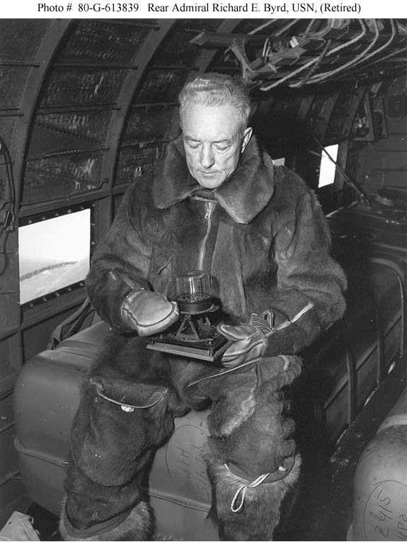
If Operation Highjump is the center of Antarctic military conspiracy theory, Admiral Byrd's Secret Diary is the center of Antarctic Hollow Earth mythology.
The document purports to record a secret flight Byrd made on February 19, 1947. According to the story, Byrd flies toward one of the polar regions and encounters something impossible. Ice disappears. The temperature rises. Green vegetation appears. He sees animals resembling mammoths. His navigation instruments behave strangely. Then mysterious disc-shaped aircraft take control of his plane and guide him toward an advanced city. Byrd eventually meets a highly advanced civilization living beneath the Earth's surface. Their leader warns him that surface humanity's development of atomic weapons has placed civilization in terrible danger.
It is wonderful material. However, no established provenance shows that Richard Byrd wrote it. Even a 2009 UFO-oriented presentation of the diary acknowledged that the story supposedly surfaced through an Art Bell program involving someone claiming a connection to the Byrd family, while actual family members reportedly disputed that person's connection and denied the diary's existence.
There is an even more interesting chronological problem. The famous diary describes an Arctic/North Pole flight on February 19, 1947. But Byrd was participating in Operation Highjump in Antarctica at precisely that time. Documented Highjump records show Byrd aboard an R4D flight over the South Pole on February 15–16, only a few days before the supposed secret Arctic flight. U.S. Navy records also place him at the Antarctic base immediately before the evacuation on February 22.
That makes the literal diary account extraordinarily difficult to reconcile with Byrd's known movements. On the other hand, some suggest this diary entry actually describes an Antarctic flight on February 19, 1947. If that is the case, Byrd is definitely in Antarctica on the date that corresponds to the diary, and his remarkable experience suddenly aligns with much of the other lore about Operation Highjump.
End Times Productions Dramatization of the Byrd Diary

VI. HOLLOW EARTH: HOLES IN THE POLES
Hollow Earth mythology predates Admiral Byrd by centuries.
Astronomer Edmond Halley proposed in 1691 that Earth might consist of concentric shells, partly to explain magnetic phenomena.
In the early nineteenth century, American Army officer John Cleves Symmes Jr. became one of the most famous advocates of a hollow Earth open at the poles. Symmes publicly declared that Earth was hollow and habitable within and proposed an expedition to enter through one of the polar openings.
This matters because the idea of polar entrances into the Earth predates Richard Byrd's flights near the poles. Byrd was eventually grafted onto an already-existing mythology.
LONGINES CHRONOSCOPE WITH RICHARD E. BYRD (December 1954)
In 1964—seven years after Byrd's death—Raymond W. Bernard published The Hollow Earth: The Greatest Geographical Discovery in History Made by Admiral Richard E. Byrd in the Mysterious Land Beyond the Poles—The True Origin of the Flying Saucers.
The Library of Congress still catalogs the book. Bernard effectively fused three previously separate subjects: Hollow Earth, Admiral Byrd, and Flying Saucers.
From that point forward they became increasingly difficult to separate in popular mythology. The later "secret diary" supplied the story with dialogue, scenery and characters.
And one group of characters became particularly important.

VII. THE ARIANNI: GUARDIANS OF THE INNER WORLD
Later versions of the alleged Byrd diary identify the inhabitants of the inner world as the Arianni, sometimes rendered Ari Anni or Aryanni. They are generally described as tall, technologically sophisticated, and Nordic-looking, sometimes speaking with a Germanic accent. Their civilization is thousands of years ahead of ours. Their aircraft are disc-shaped. They have monitored surface civilization. And they became particularly concerned when humanity detonated atomic weapons at Hiroshima and Nagasaki.
In versions of the diary circulating within Hollow Earth communities, the "Master" tells Byrd that he has entered the domain of the Arianni and explains that their civilization began closely observing surface humanity after the atomic bombings.
This brings several Antarctic legends together beautifully. Tall blond "Aryan"-looking beings. German terminology. Flying discs. Nazi interest in Antarctica. Hollow Earth. And Admiral Byrd.
Historically, however, the Arianni should be presented as later esoteric/UFO mythology associated with the unverified Byrd diary, rather than as something appearing in Byrd's authenticated writings. That distinction makes the story's evolution more interesting. The legend appears to have grown over time.
AGARTHA: THE KINGDOM BENEATH OUR FEET
Another underground civilization is worth mentioning alongside the Arianni.
Agartha—or Agharta.
Long before internet discussions of Antarctic entrances and extraterrestrial cities beneath the ice, European occult literature described a hidden civilization beneath Central Asia. One of the most influential versions came from nineteenth-century French occultist Alexandre Saint-Yves d'Alveydre, who described Agartha as an advanced subterranean kingdom ruled by a mysterious spiritual authority sometimes characterized as the King of the World.
The legend was later popularized by Ferdynand Ossendowski's 1922 book Beasts, Men and Gods. Over time, Agartha became increasingly entangled with the Tibetan tradition of Shambhala, although the two concepts have very different origins and should not historically be treated as the same thing.
Eventually, Agartha was absorbed into Hollow Earth mythology. Instead of merely being an underground kingdom somewhere beneath Asia, it became part of an enormous internal world accessible through tunnels—and, in some versions, through openings near the North and South Poles.
Now compare the Agartha mythology with the supposed Byrd diary. An advanced civilization beneath the Earth. Unknown energy sources. Superior technology. A spiritually advanced people watching humanity on the surface. Concern about mankind's destructive tendencies. Polar entrances. Flying craft.
The similarities are obvious.
In some later versions of the mythology, the various names—Agartha, Shambhala, Arianni and Inner Earth—become different descriptions of essentially the same hidden civilization.
That does not establish that any such civilization exists. But it does confirm that Admiral Byrd did not create the Inner Earth story. His name was inserted into a mythology that had already been developing for decades. And once Byrd—the world's most famous polar explorer—became attached to it, Hollow Earth suddenly acquired something earlier occult writers had never possessed:
A supposed modern eyewitness.
VIII. THE DRACO REPTILIANS AND THE ANTARCTIC BREAKAWAY CIVILIZATION
At this point, the story leaves conventional history almost entirely and enters modern "exopolitical" mythology.
In one branch of contemporary extraterrestrial lore, the Draco—or Draconian—Reptilians represent a powerful, hostile extraterrestrial civilization. Different storytellers place their origins in Draco, Orion, or related star systems and describe them as hierarchical, militaristic, and expansionist.
Eventually, this mythology became connected with Antarctica. In the most elaborate version: Nazi occult or technological programs established contact with non-human intelligences. Some of those entities were reptilian or Draconian. The Germans received advanced aerospace or antigravity technology. When Nazi Germany collapsed publicly in 1945, portions of the advanced technological program escaped to Antarctica. There, a breakaway civilization survived independently of postwar Germany. Its underground facilities eventually became associated with extraterrestrial factions and a larger "Dark Fleet" operating beyond Earth.
Modern exopolitical sources explicitly circulate versions of the story in which German elites and Draco-associated beings establish an Antarctic base. As you may surmise, no accepted historical or scientific evidence supports this scenario. It is modern UFO mythology at its finest.
But narratively, it performs an important function: It provides an explanation for how the alleged Nazi Antarctic colony could survive for decades without resupply from Germany.
The answer becomes: It was no longer simply German. This is a perfect example of how one part of mythology expands to solve problems created by earlier parts of the mythology. And with Reptilians being very newsworthy in the world of Ufology these days, you have to at least stop and ponder the possibilities.
Brad Olsen Interview on Super Soldier Talk

IX. PYRAMIDS BENEATH THE ICE
Satellite imagery has added another powerful Antarctic legend.
Images circulated online showing what appears to be an almost perfectly pyramidal structure rising from the ice in the Ellsworth Mountains. It looks artificial. And because Antarctica was once warmer millions of years ago, the inevitable question followed: Could somebody have constructed pyramids there before the continent froze?
The geological explanation is considerably less exotic. The formation is an unnamed peak in the Ellsworth Mountains. Geologists identify it as a naturally formed pyramidal mountain shaped by erosion. Similar structures—often called glacial horns—occur when glaciers erode multiple sides of a mountain. The Matterhorn is perhaps the world's most famous example.
The broader Ellsworth Mountains are a well-studied geological range containing ancient sedimentary formations and fossils. No archaeological evidence demonstrates that the Antarctic "pyramid" is artificial.
But this is another case in which the visual evidence is genuinely provocative. Show somebody the photograph without context and ask what it resembles. Most people will say a pyramid.
The more intriguing question isn't whether that particular mountain is a pyramid. It is: If an ancient civilization ever existed in Antarctica, how would we know? Almost everything it created could now lie beneath immense amounts of ice. That question is much harder to dismiss with a single photograph.
And here is one final thing to consider: Geologists who have examined the imagery and who understand the extensively studied geology of the Ellsworth Mountains consider it a natural formation. But I found no evidence of a dedicated on-site investigation specifically designed to determine whether the famous pyramid-shaped peak is artificial.
The mystery continues…
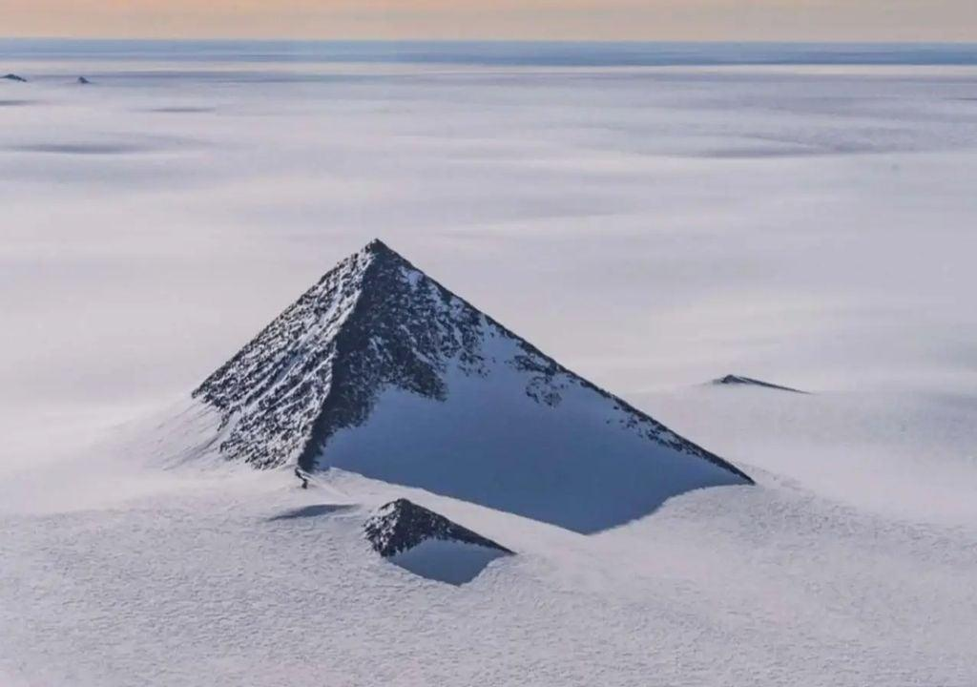

LAKE VOSTOK: THE REAL WORLD BENEATH THE ICE
While the idea of pyramids buried beneath Antarctica's ice entices the imagination of anyone who has ever contemplated ancient astronaut theory, lost civilizations, or anything in between, perhaps the most effective Antarctic mystery requires almost no embellishment.
Because an enormous hidden world genuinely lies beneath Antarctica.
Lake Vostok lies underneath approximately four kilometers—roughly two-and-a-half miles—of Antarctic ice. It is enormous. NASA describes it as about the size of Lake Ontario, and geophysical research indicates it stretches more than 250 kilometers and contains water hundreds of meters deep.
Think about that for a moment. People built a research station on an ice sheet and eventually discovered that two-and-a-half miles below their feet lay an enormous liquid lake. And Vostok is not really that unique. Scientists have now identified hundreds of subglacial lakes beneath Antarctica, some connected through hidden networks in which water moves from one buried basin to another beneath the ice sheet.
Scientists are particularly interested in these environments because they may provide analogs for extraterrestrial habitats such as the ocean believed to exist beneath the icy shell of Jupiter's moon Europa.
Even more intriguingly, scientists have identified microorganisms in accretion ice associated with Lake Vostok, and have discovered living microbial ecosystems in other Antarctic subglacial lakes.
So the question, "Is there life in hidden worlds beneath the Antarctic ice?" has an answer.
Yes. At least microbial life.
That is where scientific fact ends, and Antarctic lore takes over. Because alternative researchers have occasionally speculated about far more than bacteria.
Unknown organisms. Ancient ecosystems. Underground caverns. Artificial structures. Lost civilizations. Extraterrestrial installations. Some stories even imagine geothermal environments extensive enough to support much larger forms of life beneath the ice.
No truly credible evidence currently supports any of those extraordinary claims. But Lake Vostok changes the psychological equation. An underground Antarctic world is no longer entirely imaginary. Vast bodies of liquid water exist beneath miles of ice. Humans have barely explored some environments. There really is life beneath Antarctica. And there are hundreds of these hidden lakes. Which raises perhaps the most important question of all:
How much of the Antarctic mystery exists because we know too little—and how much exists because the things we already know sound almost unbelievable?
Dr. David Miller discusses Lake Vostok
X. THE GIANTS OF PATAGONIA
The Patagonian giants are not actually an Antarctic story. But geographically and mythologically they belong in the conversation.
Patagonia represents the southern gateway to Antarctica, separated from the Antarctic Peninsula by the Drake Passage. And European explorers really did report encountering enormous human beings there. During Magellan's circumnavigation in the early sixteenth century, chronicler Antonio Pigafetta described an indigenous man who was supposedly so tall that Europeans reached only to his waist. Pigafetta's account exists and can still be read in translations of the voyage narrative.
Stories of gigantic Patagonians persisted for roughly three centuries. Some reports inflated their heights to nine, twelve, or even fifteen feet. Later measurements told a much less spectacular story. Indigenous Patagonians were indeed often tall by contemporary European standards, but nowhere near the fantastic proportions described in earlier accounts. An eighteenth-century controversy surrounding Captain John Byron's voyage similarly shrank supposed nine-foot giants into people roughly six-and-a-half feet tall.
So were the Patagonian giants simply:
- unusually tall indigenous people exaggerated by European storytellers;
- misunderstood measurements;
- deliberate sensationalism;
- fossil discoveries confused with human remains;
- or remnants of something genuinely unusual?
Brad Olsen's Secrets of Antarctica explicitly includes the "land of the Patagonia giants" in the journey leading toward the Antarctic mysteries.
For our purposes, the giants provide an excellent bridge between ancient maps and Antarctica itself. Before Europeans even knew what lay beyond the far southern oceans, they already believed the gateway to that unknown world was inhabited by giants.
That is almost too perfect.

XI. THE REAL ICE WALL
The modern "Antarctic Ice Wall" theory is usually associated with Flat Earth beliefs.
But here again there is a fascinating kernel of reality.
Antarctica really does contain enormous walls of ice. The most famous is the seaward face of the Ross Ice Shelf, historically called the Great Ice Barrier. The Ross Ice Shelf is roughly the size of a major European country. Its outer edge can rise around 50 meters—roughly 160 feet—above the ocean, creating a near-vertical wall of ice extending for hundreds of miles. When explorer James Clark Ross encountered it in 1841, he found it so imposing that he compared penetrating it to sailing through the cliffs of Dover.
So photographs of an Antarctic "ice wall" are not necessarily fake. What changes is the interpretation.
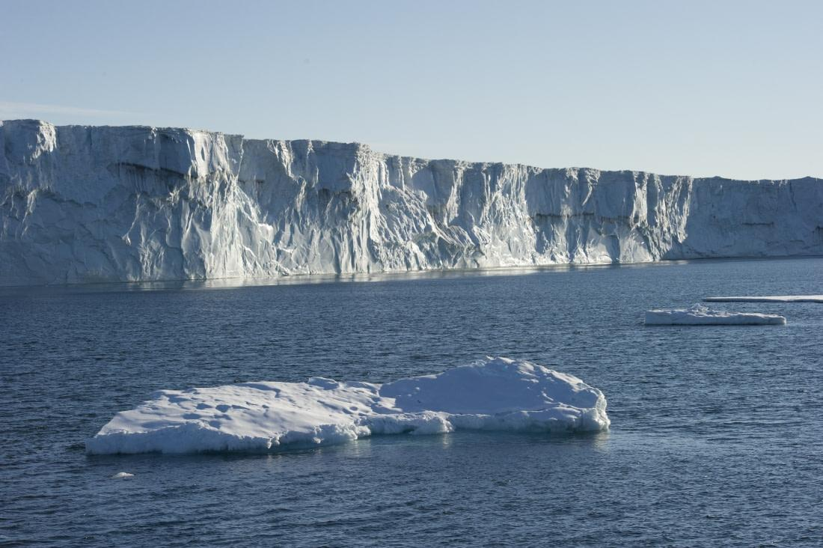
Flat Earth Antarctica
In Flat Earth cosmology, Antarctica is frequently transformed from a continent surrounding the South Pole into an enormous ring encircling the known world. This concept goes back at least to nineteenth-century Flat Earth advocate Samuel Rowbotham, whose model placed the North Pole at the center of a flat circular Earth and Antarctica around the perimeter as an ice boundary.
Modern variations ask the obvious next question: What lies beyond it? And this is where contemporary lore becomes almost science fiction.
Claims include:
- additional continents;
- hidden civilizations;
- unexplored oceans;
- enormous territories deliberately excluded from maps;
- entrances into the interior Earth;
- lands occupied by non-human civilizations;
- or territories controlled by an elite population hidden from ordinary humanity.
One widely circulated modern "map" purporting to depict continents beyond the Antarctic wall was eventually traced to a fantasy worldbuilding project rather than leaked geographical information. But the concept has become detached from any single map. The mystery now exists independently:
What if Antarctica is not the end of the map?
What lies beyond the Ice Wall?

XII. THE GRAND UNIFIED ANTARCTIC THEORY
If we combine all of these legends into a single narrative, something remarkable happens.
We get what we call the Grand Unified Antarctic Theory.
It goes something like this:
Thousands of years ago, Antarctica was either warmer or occupied by an advanced civilization. That civilization may have been Atlantean, extraterrestrial, or connected with an Inner Earth society.
Ancient navigators mapped Antarctica before it became buried beneath ice. Fragments of those maps survived and eventually appeared in the work of Piri Reis, Oronce Fine, and other Renaissance cartographers.
Secret societies later rediscovered knowledge of Antarctica's true history.
Nazi Germany became obsessed with occult archaeology and advanced technology and sent an expedition to Antarctica in 1938–39. Instead of merely surveying territory, the Germans discovered—or established—underground installations in Neuschwabenland. Advanced technology, perhaps obtained from extraterrestrials or an older civilization, allowed those installations to survive after Nazi Germany's fall. U-boats transported personnel and equipment south.
In 1946, the United States learned enough about the colony to send Operation Highjump. The American force unexpectedly encountered technologically superior craft. Highjump withdrew.
Admiral Byrd discovered that the polar regions contained far more than conventional geography suggested. He later recorded—or was alleged to have recorded—contact with an Inner Earth civilization known as the Arianni.
The major powers realized that Antarctica contained secrets too dangerous to fight over publicly. Scientific activity dramatically increased during the International Geophysical Year. The Antarctic Treaty followed shortly afterward. Governments agreed to freeze territorial disputes and limit military activity while publicly presenting Antarctica as a continent devoted to peaceful science.
Deep beneath the ice remained ancient structures, pyramids, underground facilities and perhaps entrances to a larger subterranean world.
Later extraterrestrial lore added Draco Reptilians, Nazi breakaway civilizations, and secret space programs.
And the newest generation of mythology asks whether Antarctica itself is merely the boundary of the known world—with additional lands existing beyond the ice.
Is there evidence establishing this entire mythology?
Of course not. That is why it is a mythology.
But almost every stage has at least one genuine historical ingredient.
That is why the mythology is so durable.

XII. FINAL THOUGHTS
We have covered so much ground here. But Antarctica has a deeper reason for attracting legends.
We have mapped the surface of Mars more thoroughly than most humans will ever explore the Antarctic interior. The continent is simultaneously known and inaccessible. Satellites photograph it constantly. Scientists have mapped its ice, mountains and bedrock. Research stations operate year-round.
Yet enormous areas remain places almost nobody personally visits. And underneath the ice is another Antarctica entirely. Modern radar has revealed buried mountain ranges, immense subglacial lakes, valleys and landscapes sealed away from the atmosphere for extraordinary periods of time.
That fact alone sounds like science fiction. Genuine volcanoes lie beneath Antarctic ice. There are meteorites preserved on its surface. Fossil remains show that Antarctica once supported dramatically different ecosystems. Enormous subglacial lakes lie isolated beneath kilometers of ice. Mountain peaks exist that nobody had seen closely until aircraft flew over them.
So when someone asks: "Could something be hidden under Antarctica?"
The scientifically accurate answer is actually:
Of course things are hidden under Antarctica. Most of the continent's underlying surface is hidden beneath ice.
The much harder question is what those things are.
Ultimately, Antarctica occupies a unique place in human imagination. For ancient cartographers, it was the unknown southern world. For nineteenth-century explorers it was the final geographical frontier.
For Hollow Earth believers, it became the entrance to another world.
For Nazi mythology, it became the refuge of a defeated regime.
For UFO researchers, it became a possible base for non-human intelligence.
For many, it has become something even larger: the place where all the secrets supposedly meet. Ancient maps. Lost civilizations. Giants. Nazis. Flying saucers. Admiral Byrd. Underground cities. Pyramids. Extraterrestrials. An international treaty. And an enormous wall of ice.
Perhaps the greatest reason these stories survive is that Antarctica still looks like a place where impossible things ought to happen.
It is the closest thing our modern world has to the old warning printed on unexplored portions of maps:
Here there be monsters.
Whether those monsters are extraterrestrials, Nazis, giants, forgotten civilizations—or simply our own tendency to fill blank spaces with extraordinary stories—is what makes the Legends & Lore of Antarctica such a fascinating subject.
And if even one of the stranger stories turned out to contain more truth than we currently realize, then the most mysterious continent on Earth would become something considerably more miraculous.

